**ASPECT BASED SENTIMENT ANALYSIS**

## **A Project Submitted To**

CENTER FOR DISTANCE AND ONLINE EDUCATION

BHARATI VIDYAPEETH DEEMED TO BE UNIVERSITY,

PUNE

“MCA”

Under the Faculty of Management

Submitted in partial fulfillment of the requirement for the award of degree of Master of computer application.

#### Submitted by

**Roshan Sanjay Ghadge**

#### Under the guidance of

Prof Rasika Patil

Bharati Vidyapeeth’s

School of Distance Education

Navi Mumbai

# ACKNOWLEDGEMENT

I hereby declare that the project Titled **Aspect Based Sentiment Analysis** is completed and written by me. This has not been previously submitted in any form for the award of any Degree or Diploma or other similar title of this or any other university or examining body. If it is found copied, at any stage the University can take any action it deemed fit.

Signature of Student

Roshan Ghadge

**CERTIFICATE**

This is to certify that the project title **Aspect Based Sentiment Analysis** which is being submitted herewith for the award of the Degree of (MCA) of Bharati Vidyapeeth Deemed to be University of Pune is the result of thew original project work completed by **Roshan Ghadge** under my super visioned guidance and to the best of my knowledge and belief the work embodied in the this project has not formed earlier the basis for the award of any degree or diploma or similar title of this or any other University or examining body.

Place- Nerul, Navi Mumbai

Date:

_____________________

**Prof Rasika Patil**

Project Guide

# EXECUTIVE SUMMARY

**Objective:**

The objective of the project "Aspect-Based Sentiment Analysis" is to develop a system capable of analysing text data and extracting sentiment polarity (positive, negative, or neutral) associated with specific aspects or features mentioned within the text. This technology enables businesses to gain deeper insights into customer opinions, preferences, and feedback by understanding sentiments expressed towards different aspects of their products or services.

**Key Points:**

* **Aspect Extraction:** Implement algorithms to automatically identify and extract specific aspects or features mentioned in the text. This involves natural language processing (NLP) techniques such as named entity recognition (NER) and dependency parsing.
* **Sentiment Analysis:** Develop sentiment analysis models capable of determining the polarity (positive, negative, or neutral) of sentiments expressed towards each extracted aspect. This involves training machine learning or deep learning models on labelled sentiment data.
* **Scalability and Efficiency:** Ensure that the system is scalable and efficient, capable of processing large volumes of text data in real-time or near real-time to support applications with high throughput requirements.
* **Accuracy and Reliability:** Strive for high accuracy and reliability in sentiment analysis results to provide actionable insights to businesses. This involves rigorous testing, validation, and refinement of the algorithms and models used in the system.
* **Integration and Deployment:** Develop the system with easy integration capabilities, allowing it to be seamlessly integrated into existing software applications or workflows. Provide clear documentation and support for deployment in various environments
* **Visualization and Reporting:** Implement features for visualizing sentiment analysis results and generating insightful reports. This enables stakeholders to easily interpret and act upon the analyzed sentiment data.
* **Feedback Mechanism:** Incorporate mechanisms for gathering feedback from users to continuously improve the accuracy and performance of the sentiment analysis system over time.
* **Ethical Considerations:** Address ethical considerations related to privacy, bias, and fairness in sentiment analysis, ensuring that the system respects user data privacy and provides fair and unbiased analysis results.

##### **TABLE OF CONTENTS**

|  |  |  |
| --- | --- | --- |
| **Sr. No** | **Title** | **Page No.** |
|  | **Chapter 1: Introduction of the Project** |  |
| 1.1 | Concept & Significance or Need of the Study | 8 |
| 1.2 | Objective of the Study | 9 |
| 1.3 | Scope of the study | 10 |
| 1.4 | Introduction to the topic | 12 |
|  | **Chapter 2: Introduction to Industry** |  |
| 2.1 | Overview of Industry | 13 |
| 2.2 | Major Players in the market/ Competitor Analysis | 14 |
| 2.3 | Future Trends... | 20 |
|  | **Chapter 3: Introduction to the Company** |  |
| 3.1 | vision, mission, organizational structure,  products/services, departments etc. | 23 |
| 3.2 | Description of the HR/ Marketing / Finance / Operation processes: Should include block diagrams, models for showing the processes, major operations, compositions, process conditions & regulatory aspects etc. Mention assumptions, if any & management technologies used for regulation purpose | 23 |
| 3.3 | Products, Plants, Capacity, Turnover, Market share etc. SWOT Analysis | 24 |
|  | **Chapter 4: Research Methodology** |  |
| 4.1 | Research Design | 30 |
| 4.2 | Sources of Data | 33 |
| 4.3 | Data Collection Tools and Techniques | 35 |
| 4.4 | Workflow of ABSA | 38 |
|  | **Chapter 5: Data Analysis and Interpretation**  *(Tables, graphs, statistical techniques etc.)* | 40 |
|  | **Chapter 6: Conclusion &Suggestions** |  |
| 6.1: | Findings | 56 |
| 6.2: | Suggestions | 57 |
| 6.3 | Limitations | 58 |
| 6.4 | Conclusion | 59 |
|  | **Chapter 7: Learning Experience from the project** | 60 |
|  | **Annexure**  *(Questionnaire, specimen copies of forms, other exhibits etc.)* | 63 |
|  | **Bibliography** (Books, journal articles, internet etc. referred for the project work). | 65 |

**Chapter 1: Introduction of the Project**

**1.1: Concept & Significance or Need of the Study**   
Aspect-Based Sentiment Analysis (ABSA) is a subfield of sentiment analysis that focuses on identifying and analyzing the sentiment expressed towards specific aspects or features mentioned in text data. Unlike traditional sentiment analysis, which provides an overall sentiment score for a piece of text, ABSA delves deeper into understanding the sentiment associated with different aspects of a product, service, or topic.

In ABSA, the text is analyzed to identify aspects or entities being discussed, such as product attributes (e.g., performance, design, price) or service features (e.g., customer support, usability). Then, sentiment analysis techniques are applied to determine the polarity (positive, negative, or neutral) of sentiments expressed towards each aspect.

The significance or need of the study lies in the following aspects:

* **Enhanced Insights:** ABSA provides more granular insights compared to traditional sentiment analysis, enabling businesses to understand not only whether customers are satisfied or dissatisfied but also which specific aspects of their products or services are driving those sentiments. This allows for targeted improvements and optimizations.
* **Improved Decision Making**: By understanding the sentiment associated with different aspects, businesses can make more informed decisions regarding product development, marketing strategies, customer service enhancements, and competitive positioning.
* **Customer-Centric Approach:** ABSA helps businesses adopt a customer-centric approach by focusing on the aspects that matter most to their customers. This allows for tailored responses to customer feedback and preferences, leading to increased customer satisfaction and loyalty.
* **Efficient Resource Allocation:** ABSA enables businesses to prioritize resources and efforts based on the aspects that have the greatest impact on customer satisfaction and overall business success. This ensures optimal resource allocation and maximizes return on investment.
* **Brand Reputation Management:** ABSA helps businesses monitor and manage their brand reputation by identifying and addressing negative sentiments associated with specific aspects before they escalate into larger issues. This proactive approach can mitigate reputational damage and maintain brand trust.
* **Adaptability to Different Domains:** ABSA is applicable across various domains and industries, including e-commerce, hospitality, healthcare, automotive, and more. Its flexibility allows businesses to tailor sentiment analysis models to specific contexts and requirements.

**1.2: Objective of the Study**

* **Enhance Sentiment Analysis Precision:** Develop algorithms and techniques to improve the precision and granularity of sentiment analysis by focusing on specific aspects or entities mentioned in text data, leading to more insightful and actionable sentiment analysis results.
* **Enable Targeted Feedback Analysis:** Enable businesses to analyze customer feedback in a more targeted manner by identifying sentiments associated with different aspects of their products, services, or experiences, allowing for more precise identification of areas for improvement.
* **Support Decision-Making Processes:** Provide businesses with valuable insights into customer sentiments towards various aspects of their offerings, empowering data-driven decision-making processes related to product development, marketing strategies, customer service enhancements, and competitive positioning.
* **Facilitate Customer-Centric Approaches:** Facilitate the adoption of customer-centric approaches by enabling businesses to understand and prioritize aspects that are most important to their customers, thereby improving overall customer satisfaction, loyalty, and retention.

**1.3: Scope of Study**

Aspect-Based Sentiment Analysis (ABSA) is a burgeoning field within Natural Language Processing (NLP) that aims to extract granular insights from text data by identifying specific aspects or features mentioned and analyzing the sentiment polarity associated with each aspect. The scope of this study encompasses the development and implementation of a comprehensive computational framework for ABSA, addressing various aspects such as aspect extraction, sentiment analysis, domain adaptability, and practical application.

**1. Aspect Extraction:** The study will focus on developing algorithms and techniques for accurately identifying and extracting specific aspects or entities mentioned in text data. This involves leveraging techniques from NLP, including Named Entity Recognition (NER), Part-of-Speech (POS) tagging, and dependency parsing, to identify and categorize aspects such as product attributes, service features, or topic elements.

**2. Sentiment Analysis:** A key component of the study involves sentiment analysis, where the polarity (positive, negative, or neutral) of sentiments expressed towards each extracted aspect is determined. Machine learning and deep learning approaches will be explored for training sentiment analysis models on labeled data, considering nuances in language and context to achieve accurate sentiment classification.

**3. Fine-Grained Analysis:** The study will delve into fine-grained sentiment analysis techniques to capture nuances in sentiment intensity and variations across different aspects. This involves considering contextual information, linguistic cues, and sentiment modifiers to provide a more nuanced understanding of sentiment expressions within text data.

**4. Domain Adaptability:** The ABSA framework will be designed to be adaptable to different domains and industries, allowing for the analysis of sentiments related to diverse products, services, or topics. Techniques for domain adaptation, transfer learning, and domain-specific feature engineering will be explored to ensure the effectiveness and generalizability of the sentiment analysis models across various domains.

**5. Integration and Deployment:** Practical considerations for integration and deployment will be addressed to ensure that the ABSA framework can be seamlessly integrated into existing business workflows and applications. This involves providing clear documentation, APIs, and libraries for easy integration, as well as scalability and efficiency considerations to support real-time or near real-time processing of large volumes of text data.

**6. Evaluation and Validation:** The study will include rigorous evaluation and validation of the ABSA framework to assess its accuracy, reliability, and performance. This involves testing the framework on benchmark datasets, conducting user studies or surveys to gather feedback, and comparing the results with human annotations or ground truth to validate the effectiveness of the sentiment analysis models.

**7. Practical Applications:** The scope of the study extends to practical applications of ABSA in real-world scenarios, including but not limited to customer feedback analysis, product review summarization, social media monitoring, brand reputation management, and market research. The ABSA framework will be applied to these applications to demonstrate its utility and effectiveness in providing actionable insights for businesses.

**1.4: Introduction to Topic**

In the digital era, where information is abundant and readily accessible, businesses face the challenge of extracting actionable insights from the vast amount of unstructured text data generated daily. Customer feedback, expressed through social media posts, online reviews, forums, and other platforms, contains valuable information about preferences, opinions, and sentiments. However, analyzing this data manually is impractical and time-consuming, necessitating the use of automated techniques for sentiment analysis.

Traditional sentiment analysis techniques provide a high-level assessment of sentiment polarity (positive, negative, or neutral) for a piece of text. While useful for understanding overall sentiment trends, these techniques often overlook the nuances inherent in language and fail to capture sentiments expressed towards specific aspects or features mentioned within the text. For businesses striving to improve their products, services, and customer experiences, understanding sentiment at a granular level is crucial.

**Aspect-Based Sentiment Analysis (ABSA)** has emerged as a solution to this challenge, offering a more fine-grained approach to sentiment analysis by focusing on specific aspects or entities mentioned in text data. By extracting and analyzing sentiments associated with individual aspects, ABSA provides deeper insights into customer feedback, enabling businesses to identify strengths and weaknesses in their offerings and make data-driven decisions to drive business growth and success.

**Chapter 2: Introduction to Industry**

**2.1: Overview of Aspect-Based Sentiment Analysis (ABSA)**

Aspect-Based Sentiment Analysis (ABSA) is a subfield of Natural Language Processing (NLP) and sentiment analysis that focuses on extracting fine-grained sentiment information from text data by considering specific aspects or features mentioned within the text. Unlike traditional sentiment analysis, which provides an overall sentiment score for a piece of text, ABSA aims to identify and analyze sentiments towards individual aspects or entities mentioned in the text, providing a more nuanced understanding of the sentiment

* **Deeper Insights:** it provides deeper insights into customer sentiments by analyzing sentiments towards specific aspects/features mentioned within the text.
* **Actionable Insights:** By identifying sentiments towards individual aspects, ABSA enables businesses to take targeted actions to address customer concerns and improve overall satisfaction.
* **Competitive Advantage:** Understanding sentiments towards different aspects of products or services can provide businesses with a competitive advantage by identifying areas for differentiation and improvement.
* **Efficient Resource Allocation:** ABSA enables businesses to prioritize resources and efforts based on the aspects that have the greatest impact on customer satisfaction and overall business success expressed.
* **Product Reviews:** Analyzing sentiments expressed towards different product features mentioned in online reviews to identify areas for product improvement.
* **Customer Feedback Analysis:** Understanding sentiments expressed by customers towards different aspects of a service or experience to improve customer satisfaction.

**2.2 Analysis of Aspect Based Sentiment analysis**

Aspect-Based Sentiment Analysis (ABSA) is a powerful technique for extracting fine-grained sentiment information from text data, enabling businesses to gain deeper insights into customer opinions, preferences, and feedback. In this analysis, we will examine the key strengths, limitations, and potential challenges of ABSA, as well as its applications and implications for various industries.

**1. Strengths:**

* **Granular Insights:** One of the primary strengths of ABSA is its ability to provide granular insights into customer sentiments by analyzing sentiments towards specific aspects or features mentioned within the text. This allows businesses to understand not only whether customers are satisfied or dissatisfied but also which specific aspects of their products or services are driving those sentiments.
* **Targeted Actions:** By identifying sentiments towards individual aspects, ABSA enables businesses to take targeted actions to address customer concerns and improve overall satisfaction. For example, if customers express dissatisfaction with a particular feature of a product, businesses can focus their efforts on improving that feature to meet customer expectations.
* **Domain Adaptability:** ABSA techniques can be adapted to different domains and industries, making them applicable across a wide range of applications. Whether analyzing product reviews, customer feedback, social media posts, or market research data, ABSA can provide valuable insights into customer sentiments in various contexts.
* **Scalability:** With the advancement of machine learning and NLP techniques, ABSA can be scaled to analyze large volumes of text data efficiently. This scalability allows businesses to analyze customer sentiments at scale and derive actionable insights from diverse sources of text data.

**2. Limitations:**

* **Aspect Identification Challenges:** One of the main challenges of ABSA is accurately identifying and extracting specific aspects or features mentioned within the text. While techniques such as Named Entity Recognition (NER) and dependency parsing can help with aspect extraction, they may struggle with ambiguous or context-dependent aspects.
* **Contextual Understanding:** ABSA may struggle with understanding the contextual nuances of language, leading to misinterpretations of sentiment expressions. For example, sarcasm, irony, or implicit sentiment may be difficult for ABSA systems to detect accurately, resulting in errors in sentiment analysis.
* **Data Availability and Quality:** ABSA relies heavily on labelled data for training sentiment analysis models, and the availability and quality of labelled data can pose challenges, especially in niche domains or languages. Additionally, biased or noisy data can impact the performance and reliability of ABSA systems.

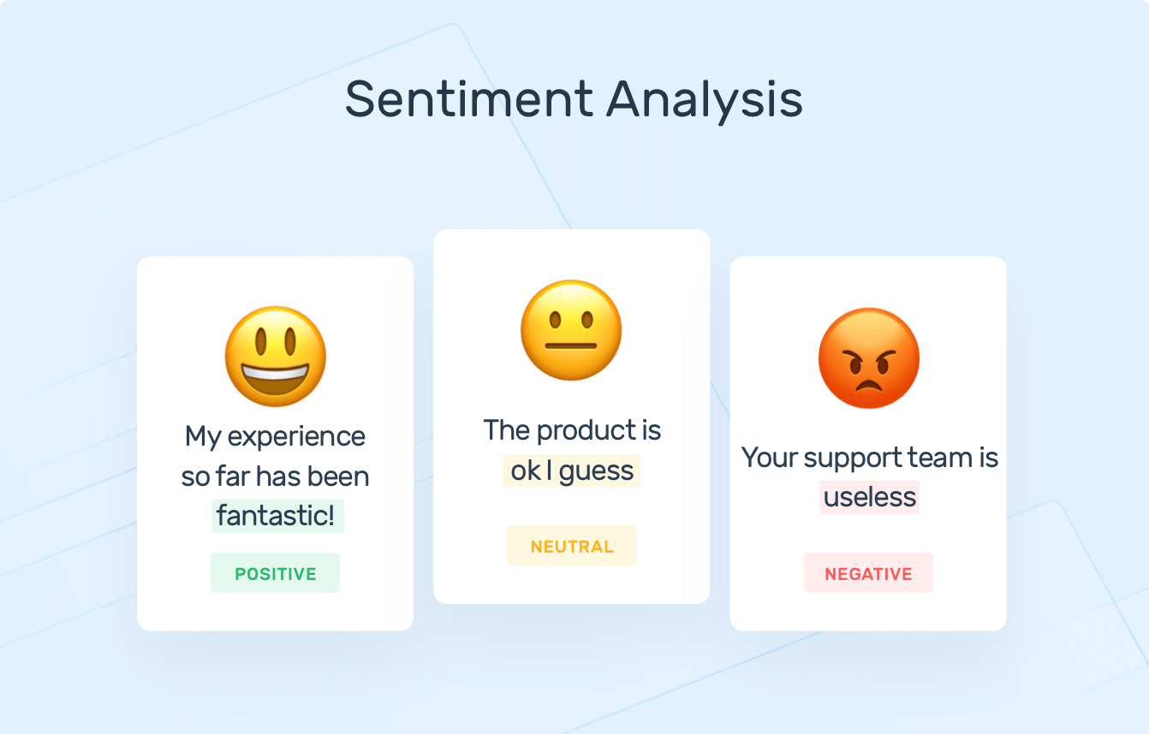

**3. Applications:**

* **Product Reviews:** ABSA is widely used in analyzing product reviews to understand sentiments towards different aspects of products, such as performance, design, features, and customer service.
* **Customer Feedback Analysis:** ABSA helps businesses analyze customer feedback across various channels, including surveys, emails, and online forums, to identify areas for improvement and enhance overall customer satisfaction.
* **Brand Reputation Management:** ABSA enables businesses to monitor and manage their brand reputation by analyzing sentiments expressed towards their brand or company across social media platforms and online communities.
* **Market Research:** ABSA can be used in market research to analyze sentiments towards competitors' products, industry trends, or emerging technologies, providing insights for strategic decision-making.

**4. Implications:**

* **Customer-Centric Approach:** ABSA promotes a customer-centric approach by focusing on aspects that are most important to customers and prioritizing actions to address their needs and preferences.
* **Competitive Advantage:** Businesses that leverage ABSA to gain deeper insights into customer sentiments can gain a competitive advantage by identifying areas for differentiation and innovation.
* **Data Privacy and Ethics:** The widespread adoption of ABSA raises concerns about data privacy and ethics, particularly regarding the collection and analysis of customer feedback. Businesses must ensure that they adhere to ethical guidelines and regulations to protect customer privacy and prevent misuse of data.

**2.2.1 Current Scenario of Aspect based Sentiment analysis**

Aspect-Based Sentiment Analysis (ABSA) has witnessed significant advancements and widespread adoption in recent years, driven by the growing demand for granular insights into customer sentiments across various industries. In this analysis, we will explore the current landscape of ABSA, including emerging trends, challenges, and applications in today's data-driven world.

**1. Adoption Across Industries:**

ABSA has gained traction across a wide range of industries, including e-commerce, hospitality, healthcare, automotive, finance, and more. Businesses in these industries leverage ABSA to analyze customer feedback, product reviews, social media posts, and other forms of text data to gain insights into customer sentiments towards specific aspects or features of their products or services.

**For example,** in the e-commerce industry, ABSA is used to analyze product reviews to understand sentiments towards different product attributes such as quality, price, shipping, and customer service. Similarly, in the hospitality industry, ABSA helps hotels and resorts analyze guest reviews to identify areas for improvement in amenities, cleanliness, staff behaviour, and overall guest experience.

**2. Advanced NLP Techniques:**

Advancements in Natural Language Processing (NLP) techniques have played a crucial role in enhancing the capabilities of ABSA. Deep learning models, such as recurrent neural networks (RNNs), convolutional neural networks (CNNs), and transformer-based models like BERT and GPT, have shown remarkable performance in sentiment analysis tasks, including aspect extraction and sentiment classification.

These advanced NLP techniques enable ABSA systems to capture contextual nuances in language, handle ambiguous or implicit sentiments, and provide more accurate and reliable sentiment analysis results. Additionally, pre-trained language models trained on large text corpora have become increasingly popular for transfer learning in ABSA, allowing models to adapt to specific domains or languages with minimal labelled data.

**3. Integration with Business Intelligence Tools:**

ABSA is increasingly being integrated with business intelligence (BI) tools and analytics platforms to provide actionable insights to decision-makers. By incorporating ABSA capabilities into BI dashboards and reporting tools, businesses can visualize sentiment analysis results alongside other key performance indicators (KPIs) and metrics, enabling stakeholders to make data-driven decisions in real-time.

For example, BI dashboards may include sentiment analysis widgets that display sentiment trends over time, sentiment distributions across different aspects or features, and sentiment scores for individual products or services. This integration allows businesses to identify emerging trends, track the impact of marketing campaigns or product launches on customer sentiment, and make timely adjustments to strategies and tactics.

**4. Challenges and Limitations:**

Despite its widespread adoption and advancements, ABSA still faces several challenges and limitations that need to be addressed:

* **Aspect Identification:** Accurately identifying and extracting specific aspects or features mentioned in text data remains a challenge, especially in cases where aspects are ambiguous, context-dependent, or domain-specific.
* **Contextual Understanding:** ABSA systems may struggle with understanding the contextual nuances of language, including sarcasm, irony, or implicit sentiment, which can lead to errors in sentiment analysis.
* **Data Quality and Bias:** ABSA relies heavily on labelled data for training sentiment analysis models, and the availability and quality of labelled data can vary across domains and languages. Additionally, biased, or noisy data can impact the performance and reliability of ABSA systems.

**5. Emerging Trends:**

* **Multi-Aspect Sentiment Analysis:** Researchers are exploring techniques for analyzing sentiments towards multiple aspects simultaneously, allowing ABSA systems to capture complex relationships and interactions between different aspects or features mentioned in text data.
* **Cross-Domain Adaptability:** Techniques for domain adaptation and transfer learning are being developed to enhance the adaptability of ABSA systems across different domains and industries, enabling models to generalize well to new contexts with minimal labelled data. Ethical Considerations: There is growing awareness of ethical considerations related to ABSA, including privacy, bias, fairness, and transparency. Researchers and practitioners are working to develop ethical guidelines and frameworks for responsible development and deployment of ABSA systems.

**6. Future Directions:**

* **Research and innovation:** Improved Aspect Identification: Advancements in NLP techniques, such as contextualized embeddings and attention mechanisms, hold promise for improving aspect identification in ABSA, enabling more accurate and robust sentiment analysis.
* **Interpretability and Explainability:** Researchers are exploring techniques for enhancing the interpretability and explainability of ABSA models, allowing stakeholders to understand how sentiment analysis decisions are made and trust the results.
* **Multimodal ABSA:** The integration of text with other modalities, such as images, videos, and audio, presents opportunities for multimodal ABSA, enabling more comprehensive analysis of customer feedback across different channels and mediums.

**2.3 Future Trends of Aspect-Based Sentiment Analysis:**

Aspect-Based Sentiment Analysis (ABSA) is poised to undergo significant advancements and innovations in the coming years, driven by emerging trends in natural language processing (NLP), machine learning, and data analytics. In this analysis, we will explore the future trends shaping the evolution of ABSA and its potential implications for businesses and researchers.

**1. Enhanced Aspect Identification:**

One of the key future trends in ABSA is the development of more advanced techniques for aspect identification. Researchers are exploring novel approaches, including deep learning models with attention mechanisms, contextualized embeddings, and graph-based methods, to improve the accuracy and robustness of aspect extraction in ABSA.

These advanced techniques aim to address challenges such as ambiguity, context-dependence, and domain-specificity in aspect identification, enabling ABSA systems to accurately identify and extract specific aspects or features mentioned in text data across diverse domains and languages.

**2. Contextual Understanding:**

Future advancements in ABSA will focus on improving the contextual understanding of sentiment expressions in text data. Researchers are exploring techniques for capturing contextual nuances, including sarcasm, irony, and implicit sentiment, to enhance the accuracy and reliability of sentiment analysis results.

This involves leveraging contextual embeddings, transformer-based models, and deep contextualized representations to capture subtle nuances in language and infer sentiment within the appropriate context. By improving contextual understanding, ABSA systems   
  
  
can provide more nuanced and accurate sentiment analysis results, leading to better decision-making and actionable insights for businesses.

**3. Multi-Aspect Sentiment Analysis:**

Another future trend in ABSA is the development of techniques for multi-aspect sentiment analysis, where sentiments towards multiple aspects or features are analyzed simultaneously. Traditional ABSA approaches focus on analyzing sentiments towards individual aspects separately, but multi-aspect sentiment analysis enables ABSA systems to capture complex relationships and interactions between different aspects mentioned in text data.

Researchers are exploring methods for modelling aspect dependencies, aspect interactions, and aspect-level sentiment propagation to achieve a more comprehensive understanding of sentiment expressions within text data. By considering multiple aspects simultaneously, multi-aspect sentiment analysis can provide more holistic insights into customer feedback and preferences, enabling businesses to make more informed decisions and drive product innovation.

**4. Cross-Domain Adaptability:**

Future ABSA systems will exhibit greater cross-domain adaptability, allowing models to generalize well to new domains and industries with minimal labeled data. Techniques for domain adaptation, transfer learning, and domain-specific feature engineering are being developed to enhance the adaptability of ABSA systems across diverse contexts and applications.  
These techniques enable ABSA models to leverage knowledge learned from one domain to improve performance in a related domain, reducing the need for extensive labeled data and manual annotation efforts. By achieving greater cross-domain adaptability, ABSA systems can be applied more effectively across various industries, including e-commerce, hospitality, healthcare, finance, and more.

**5. Ethical Considerations and Responsible AI:**

As ABSA continues to evolve, there is increasing emphasis on ethical considerations and responsible AI practices. Researchers and practitioners are working to develop ethical guidelines, fairness metrics, and transparency mechanisms to ensure that ABSA systems adhere to ethical principles and respect user privacy, dignity, and rights.

This involves addressing issues such as bias, fairness, interpretability, and accountability in ABSA models and algorithms. By incorporating ethical considerations into the design, development, and deployment of ABSA systems, businesses can build trust with users, mitigate risks, and ensure that ABSA technologies benefit society as a whole.

**6. Multimodal ABSA:**

The integration of text with other modalities, such as images, videos, and audio, presents opportunities for multimodal ABSA, where sentiment analysis is performed across multiple modalities simultaneously. Future ABSA systems will leverage multimodal data sources to provide more comprehensive and holistic insights into customer sentiments and preferences.

For example, in e-commerce, multimodal ABSA can analyse product reviews that include text descriptions, images of products, and videos of product demonstrations to gain a deeper understanding of customer sentiments towards different aspects of products. By   
incorporating multimodal data sources, ABSA systems can capture richer and more nuanced insights, enabling businesses to make more informed decisions and enhance customer experiences

**Chapter 3: Introduction to the Aspect Based Sentiment Analysis**

**3.1 Vision for Aspect-Based Sentiment Analysis (ABSA) Project:**

To revolutionize the way businesses, understand and respond to customer sentiments by providing a comprehensive and nuanced analysis of feedback, enabling data-driven decisions and fostering customer-centric innovation.

**3.2 Mission for Aspect-Based Sentiment Analysis (ABSA) Project:**

* **Advance Research and Innovation:** Continuously push the boundaries of natural language processing (NLP) and sentiment analysis to develop cutting-edge techniques and methodologies for aspect-based sentiment analysis.
* **Provide Actionable Insights:** Empower businesses with actionable insights into customer sentiments towards specific aspects or features of their products, services, or experiences, enabling them to identify areas for improvement and drive customer satisfaction and loyalty.
* **Ensure Accuracy and Reliability:** Develop robust algorithms and models for aspect extraction and sentiment analysis that deliver accurate and reliable results across diverse domains and languages.
* **Promote Ethical AI Practices:** Uphold ethical principles and responsible AI practices in the development and deployment of ABSA technologies, ensuring fairness, transparency, and respect for user privacy and rights.
* **Enable Cross-Domain Adaptability:** Develop ABSA frameworks that are adaptable to different industries and contexts, allowing businesses to apply sentiment analysis techniques effectively across various domains and applications.
* **Facilitate Business Decision-Making:** Provide businesses with the tools and methodologies needed to make data-driven decisions based on customer feedback, market trends, and competitive insights derived from aspect-based sentiment analysis.
* **Drive Customer-Centric Innovation:** Foster a culture of customer-centric innovation by prioritizing aspects that are most important to customers and continuously iterating and improving products, services, and experiences based on customer feedback and preferences.
* **Empower Stakeholders:** Empower stakeholders, including business leaders, marketers, product managers, and customer service representatives, with the knowledge and skills to leverage ABSA technologies effectively for improved decision-making and customer engagement.

**3.3 SWOT Analysis of Aspect-Based Sentiment Analysis Project:**

Aspect-Based Sentiment Analysis (ABSA) project aims to revolutionize the way businesses understand and respond to customer sentiments by providing a comprehensive and nuanced analysis of feedback. Conducting a SWOT (Strengths, Weaknesses, Opportunities, Threats) analysis can help assess the project's current state and identify areas for improvement and growth.

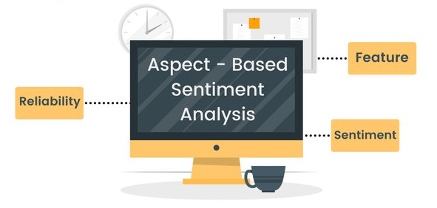

**Strengths**

* **Granular Insights:** ABSA provides granular insights into customer sentiments by analyzing sentiments towards specific aspects or features mentioned within text data. This allows businesses to understand not only whether customers are satisfied or dissatisfied but also which specific aspects of their products or services are driving those sentiments.
* **Targeted Actions:** By identifying sentiments towards individual aspects, ABSA enables businesses to take targeted actions to address customer concerns and improve overall satisfaction. This targeted approach allows businesses to allocate resources effectively and prioritize improvements based on customer feedback.
* **Domain Adaptability:** ABSA techniques can be adapted to different domains and industries, making them applicable across a wide range of applications. This flexibility allows businesses to analyse sentiments related to diverse products, services, or topics, regardless of the industry or domain.
* **Advanced NLP Techniques:** Advancements in natural language processing (NLP) techniques, such as deep learning models and transformer-based architectures, have improved the accuracy and reliability of ABSA systems. These advanced techniques enable ABSA models to capture contextual nuances in language and provide more accurate sentiment analysis results.
* **Integration with Business Intelligence Tools:** ABSA can be integrated with business intelligence (BI) tools and analytics platforms to provide actionable insights to decision-makers. By incorporating ABSA capabilities into BI dashboards and reporting tools, businesses can visualize sentiment analysis results alongside other key performance indicators (KPIs) and metrics, enabling stakeholders to make data-driven decisions in real-time.

**Weaknesses:**

* **Aspect Identification Challenges:** Accurately identifying and extracting specific aspects or features mentioned in text data remains a challenge for ABSA systems. Ambiguity, context-dependence, and domain-specificity can make aspect identification difficult, leading to errors in sentiment analysis.
* **Contextual Understanding:** ABSA systems may struggle with understanding the contextual nuances of language, including sarcasm, irony, or implicit sentiment. Misinterpretations of sentiment expressions can occur, particularly in cases where contextual information is crucial for accurate analysis.
* **Data Quality:** ABSA relies heavily on labelled data for training sentiment analysis models, and the availability and quality of labelled data can vary across domains and languages. Biased or noisy data can impact the performance and reliability of ABSA systems, leading to skewed results and inaccurate insights.
* **Ethical Considerations**: The widespread adoption of ABSA raises ethical considerations related to privacy, bias, fairness, and transparency. Businesses must ensure that they adhere to ethical guidelines and regulations to protect customer privacy and prevent misuse of data in sentiment analysis.

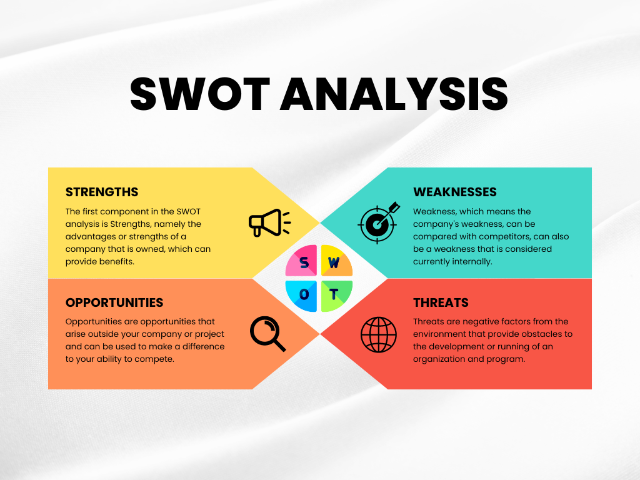

**Opportunities:**

* Multi-Aspect Sentiment Analysis: Emerging trends in ABSA include the development of techniques for multi-aspect sentiment analysis, where sentiments towards multiple aspects or features are analysed simultaneously. Multi-aspect sentiment analysis enables ABSA systems to capture complex relationships and interactions between different aspects mentioned in text data, providing more comprehensive insights into customer feedback and preferences.
* Cross-Domain Adaptability: Future ABSA systems will exhibit greater cross-domain adaptability, allowing models to generalize well to new domains and industries with minimal labelled data. Techniques for domain adaptation, transfer learning, and domain-specific feature engineering are being developed to enhance the adaptability of ABSA systems across diverse contexts and applications.
* Integration with Multimodal Data: The integration of text with other modalities, such as images, videos, and audio, presents opportunities for multimodal ABSA. Future ABSA systems will leverage multimodal data sources to provide more comprehensive and holistic insights into customer sentiments and preferences, enabling businesses to make more informed decisions and enhance customer experiences.
* Enhanced Interpretability and Explainability: Researchers are exploring techniques for enhancing the interpretability and explainability of ABSA models, allowing stakeholders to understand how sentiment analysis decisions are made and trust the results. Improved interpretability and explainability can increase confidence in ABSA systems and facilitate adoption by businesses and stakeholders.

**Threats:**

* Competition: The field of sentiment analysis is highly competitive, with numerous companies and research institutions developing ABSA technologies. Increased competition may pose a threat to the success of the ABSA project, particularly if competitors develop more advanced or innovative solutions that outperform existing ABSA systems.
* Technological Advancements: Rapid advancements in technology, particularly in NLP and machine learning, may render existing ABSA techniques obsolete or outdated. Keeping up with the latest technological advancements and incorporating them into ABSA systems will be crucial to maintaining competitiveness and relevance in the field.
* Regulatory Compliance: Regulatory requirements related to data privacy, consumer protection, and ethical considerations may pose challenges for ABSA projects. Businesses must ensure compliance with relevant regulations and standards to avoid legal and reputational risks associated with non-compliance.
* Data Security Risks: ABSA projects may be vulnerable to data security risks, including unauthorized access, data breaches, and cyberattacks. Protecting sensitive customer data and ensuring data security and confidentiality will be essential to maintain trust and credibility in ABSA systems.

**Example: -**

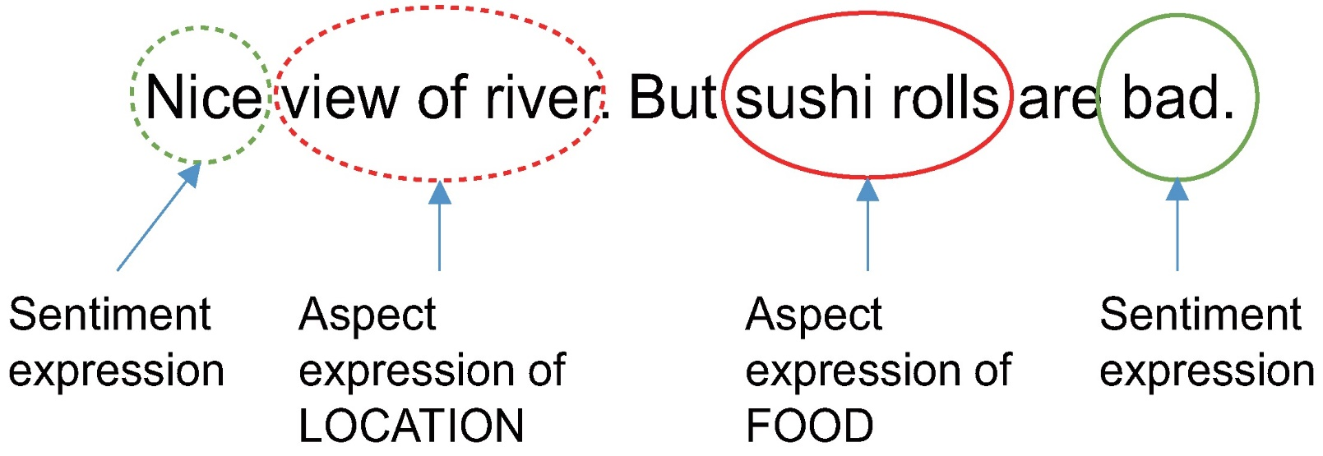

**Chapter 4: Research Methodology**

**4.1 Research Design for Aspect-Based Sentiment Analysis Project:**

The research design for an Aspect-Based Sentiment Analysis (ABSA) project encompasses the methodology, data collection, analysis techniques, and evaluation metrics used to achieve the project objectives. Here is a comprehensive overview of the research design for an ABSA project:

**1. Research Objectives:**

Define clear and specific research objectives that align with the goals of the ABSA project. For example, the objectives may include developing robust algorithms for aspect extraction, sentiment classification, and fine-grained sentiment analysis.

Specify the intended outcomes of the research, such as improved accuracy, scalability, and generalizability of ABSA models across different domains and languages.

**2. Methodology:**

Choose appropriate methodologies for aspect extraction, sentiment classification, and sentiment analysis. This may involve a combination of rule-based, machine learning, and deep learning techniques.

Determine the data preprocessing steps, including text normalization, tokenization, stemming, and stop-word removal, to prepare the text data for analysis.

Select suitable feature representation methods, such as bag-of-words, word embeddings, or contextualized embeddings, to encode the textual information for modelling.

**3. Data Collection:**

Collect relevant text data from sources such as product reviews, social media posts, customer feedback surveys, and online forums. Ensure that the data cover a diverse range of topics, domains, and languages to facilitate comprehensive analysis.

Annotate the data with aspect labels and sentiment labels to create labeled datasets for training and evaluation purposes. This may involve manual annotation by domain experts or crowdsourcing platforms.

**4. Model Development:**

Develop algorithms and models for aspect extraction, sentiment classification, and fine-grained sentiment analysis. Experiment with different architectures, such as recurrent neural networks (RNNs), convolutional neural networks (CNNs), and transformer-based models, to identify the most effective approach.

Train the models using the labelled datasets created during the data collection phase. Employ techniques such as cross-validation and hyperparameter tuning to optimize model performance and generalizability.

**5. Evaluation Metrics:**

Define evaluation metrics to assess the performance of the ABSA models accurately. Common evaluation metrics for aspect-based sentiment analysis include precision, recall, F1-score, accuracy, and mean squared error (MSE) for sentiment polarity prediction.

Consider domain-specific evaluation metrics or qualitative assessments to capture the nuances of sentiment analysis in specific industries or contexts.

**6. Validation and Testing:**

Validate the trained ABSA models using held-out validation datasets or cross-validation techniques to ensure robustness and generalizability.

Conduct rigorous testing of the ABSA models on unseen data to evaluate their performance in real-world scenarios. This may involve deploying the models in a production environment or conducting user studies to gather feedback from stakeholders.

**7. Iterative Improvement:**

Iterate on the research design based on the results of validation and testing. Identify areas for improvement, such as model performance, computational efficiency, or scalability, and refine the methodologies accordingly.

Continuously update the ABSA models with new data and feedback to adapt to evolving trends, domains, and user preferences.

**8. Documentation and Reporting:**

Document all aspects of the research design, including methodologies, data collection procedures, model architectures, evaluation results, and conclusions.

Prepare comprehensive reports and research papers summarizing the findings of the ABSA project. Communicate the research outcomes effectively to stakeholders, researchers, and the broader community through publications, presentations, and online platforms.

**4.2 Source of Data for Aspect Based Sentiment Analysis Project**

The sources of data used for Aspect-Based Sentiment Analysis (ABSA) projects vary depending on the specific objectives, domain, and context of the analysis. Here are some common sources of data that may be utilized for ABSA projects

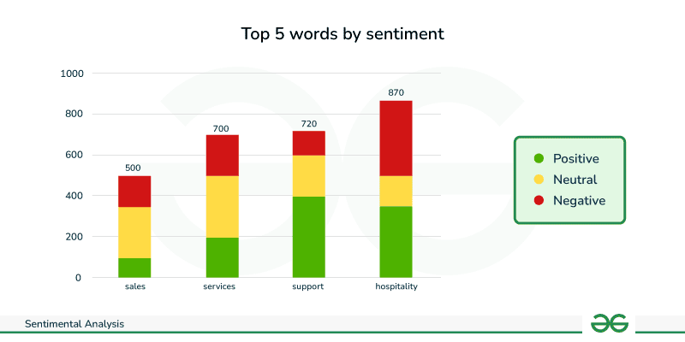

1. **Product Reviews:** Online platforms such as Amazon, Yelp, TripAdvisor, and Google Reviews provide a wealth of product and service reviews written by consumers. These reviews often contain detailed opinions and sentiments towards specific aspects or features of products or services, making them valuable sources of data for ABSA projects.
2. **Social Media Posts:** Social media platforms like Twitter, Facebook, Instagram, and LinkedIn host vast amounts of user-generated content, including posts, comments, and tweets. Social media data can provide real-time insights into public opinion, sentiments, and discussions related to various topics, brands, and events, making it a valuable source for ABSA projects.
3. **Customer Feedback Surveys:** Businesses often collect feedback from customers through surveys, feedback forms, and questionnaires. These feedback channels allow businesses to gather structured data on customer experiences, preferences, and sentiments towards different aspects of products or services, providing valuable insights for ABSA analysis.
4. **Online Forums and Communities:** Online forums, discussion boards, and community websites like Reddit, Quora, and Stack Overflow host discussions on a wide range of topics and domains. These platforms can provide rich and diverse textual data containing opinions, experiences, and sentiments expressed by users, making them useful sources for ABSA projects.
5. **E-commerce Websites:** E-commerce websites and marketplaces such as eBay, Etsy, and Alibaba offer product descriptions, customer reviews, and user-generated content related to various products and categories. Analyzing textual data from e-commerce platforms can reveal insights into customer sentiments towards product features, pricing, shipping, and more.
6. **Customer Support Interactions:** Customer support interactions, including emails, chat transcripts, and helpdesk tickets, contain valuable information about customer inquiries, complaints, and feedback. Analyzing text data from customer support interactions can help businesses identify common issues, sentiment trends, and areas for improvement in customer service.
7. **Domain-Specific Data Sources:** Depending on the specific domain or industry of interest, additional sources of data may be relevant for ABSA projects. For example, healthcare organizations may utilize electronic health records (EHRs) and patient satisfaction surveys, while financial institutions may analyse text data from customer reviews and financial reports.
8. **Custom Data Collection:** In some cases, researchers or businesses may collect custom data tailored to their specific research questions or objectives. This may involve web scraping, data crawling, or manual data collection methods to gather relevant textual data from online sources or proprietary databases.

**4.3 Data Collection Tools & Techniques**   
Data collection for Aspect-Based Sentiment Analysis (ABSA) projects involves gathering textual data from various sources, such as product reviews, social media posts, customer feedback surveys, and online forums. Here are some common data collection tools and techniques used for ABSA projects:

**1. Web Scraping**

Web scraping involves automatically extracting data from websites using specialized tools or libraries such as Beautiful Soup (for Python) or Scrapy.Researchers can write scripts to crawl websites and extract relevant textual data, including product reviews, social media posts, forum discussions, and blog comments.

Web scraping allows for large-scale data collection from multiple online sources, providing a diverse and comprehensive dataset for ABSA analysis.

**2. Application Programming Interfaces (APIs)**

Many online platforms, such as Twitter, Facebook, and Amazon, provide APIs that allow developers to access and retrieve data programmatically. Researchers can use APIs to collect textual data, including tweets, posts, comments, and reviews, from these platforms in a structured and efficient manner. APIs often have rate limits and usage restrictions, so researchers should review and adhere to the API documentation and terms of service.

**3. Data Aggregation Platforms**

Data aggregation platforms like GDELT, Common Crawl, and Kaggle datasets host large repositories of publicly available textual data, including news articles, blog posts, and social media content. Researchers can explore these platforms to find relevant datasets for ABSA projects and download the data for analysis.

Some platforms offer data preprocessing and annotation services, making it easier for researchers to access labelled datasets for sentiment analysis.

**4. Custom Data Collection Surveys**

Researchers or businesses can design and distribute custom surveys or feedback forms to collect textual data from targeted respondents. Surveys can be distributed through email, online platforms, social media channels, or dedicated survey platforms like SurveyMonkey or Google Forms. Survey questions can be tailored to gather opinions, experiences, and sentiments towards specific aspects or features of products, services, or experiences.

**5. Data Annotation and Labelling**

Data annotation involves manually labelling textual data with aspect and sentiment labels to create labelled datasets for training and evaluation purposes. Researchers can use annotation tools and platforms such as Prodigy, Label box, or Amazon Mechanical Turk (MTurk) to annotate textual data efficiently. Annotation tasks may include aspect extraction, sentiment classification, or fine-grained sentiment analysis, depending on the objectives of the ABSA project.

**6. Data Preprocessing Techniques:**

Before analysis, textual data collected from various sources may require preprocessing to clean, normalize, and format the text. Common preprocessing techniques include tokenization, stemming, lemmatization, stop-word removal, and text normalization.

Researchers can use programming languages such as Python with libraries like NLTK, spaCy, or scikit-learn to perform data preprocessing tasks efficiently.

**7. Data Privacy and Ethics Considerations:**

It's essential to consider data privacy and ethics when collecting textual data for ABSA projects, especially when dealing with user-generated content from online platforms.

Researchers should obtain informed consent from participants, anonymize sensitive information, and comply with relevant privacy regulations and guidelines.Ethical considerations such as bias, fairness, and transparency should also be considered when collecting and analyzing textual data for ABSA projects.

**4.4 Workflow of Aspect Based Sentiment Analysis project**

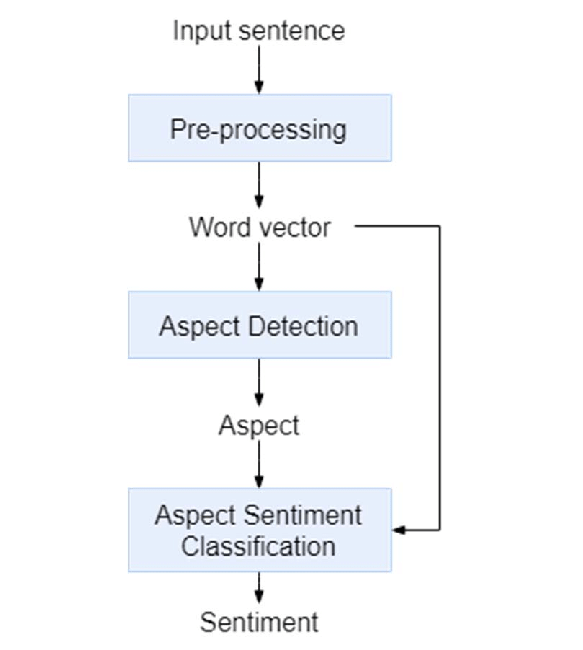

1. **Input Sentence:** The process starts with a sentence you provide as input. This sentence likely expresses an opinion or sentiment about something.
2. **Pre-processing:** The system performs some preprocessing on the sentence to prepare it for analysis. This might involve steps like tokenization (breaking the sentence into individual words) and removing punctuation or stop words (common words like "the" or "a" that do not carry much meaning).
3. **Word Vector:** Each word in the pre-processed sentence is converted into a numerical representation, often called a word vector. This vector captures the word's meaning and its relationships to other words.
4. **Aspect Detection:** The system identifies the aspects or entities that the sentence is talking about. For instance, if the sentence is "The food was delicious, but the service was slow," the aspects would be "food" and "service".
5. **Aspect Sentiment Classification:** After identifying the aspects, the system classifies the sentiment expressed towards each aspect. In the example, it would determine that the sentiment towards "food" is positive ("delicious") and the sentiment towards "service" is negative ("slow")
6. **Sentiment:** Finally, the system combines the sentiment classifications for all identified aspects to provide an overall sentiment for the sentence.

**Chapter 5: Data Analysis and Interpretation**

**5.1 Software/Hardware Requirement Specification**

**Software Requirement**

|  |  |
| --- | --- |
| Operating System | Windows 7 or above |
| Software | Pycharm/IDLE, |
| Programming languages/Technology | Python, Ai- Natural language processing, ML |
| Editor | Pycharm |

**Minimum Hardware Requirement**

|  |  |
| --- | --- |
| Processor | Intel I3 Or Above |
| Ram | 4 Gb |
| Hard Disk | 500 Gb |

**5.2 Workflow Aspect Based Sentiment Analysis Project**

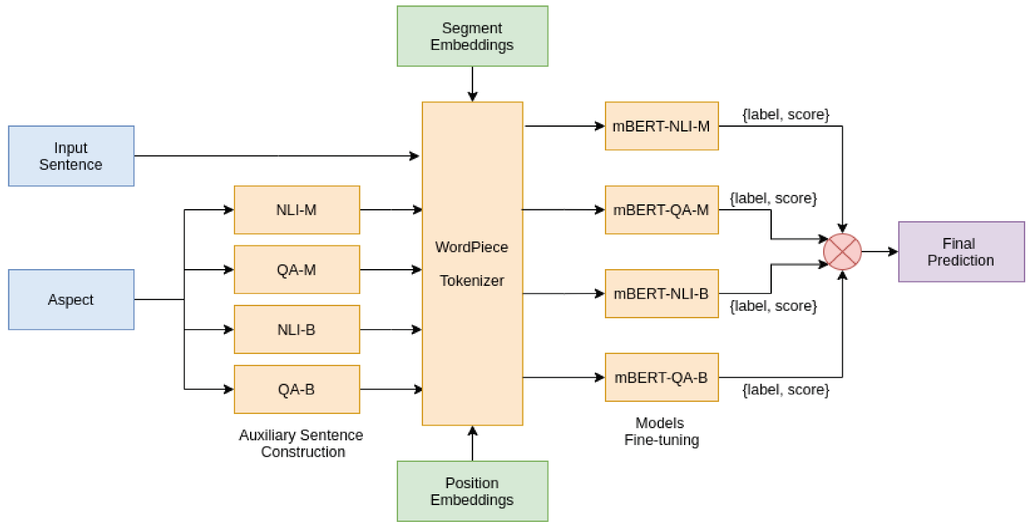

**Entities:**

1. **Sentence**: This entity represents the input sentence containing an opinion or sentiment.
2. **Word**: This entity represents an individual word within the sentence.
3. **Aspect**: This entity represents the entity or topic the sentence is discussing.
4. **Sentiment**: This entity represents the sentiment expressed towards an aspect.

Aspect-based sentiment analysis aims to understand the sentiment expressed towards specific aspects or entities mentioned in text. Here is a breakdown of a typical workflow:

1. **Data Collection:**
   * The process begins by gathering textual data relevant to your analysis domain. This could involve customer reviews, social media posts, news articles, or any other source containing opinions.
2. **Data Preprocessing:**

The collected data might need cleaning and preparation before analysis. This could involve:

* + **Tokenization:** Splitting the text into individual words or meaningful units.
  + **Normalization:** Converting text to lowercase, stemming (reducing words to their base form), or lemmatization (converting words to their dictionary form).
  + **Stop Word Removal:** Removing common words that don't contribute much to sentiment analysis (e.g., "the," "a," "is").
  + **Part-of-Speech (POS) Tagging:** Identifying the grammatical function of each word (e.g., noun, verb, adjective).

1. **Sentence Segmentation:**
   * The pre-processed text might need to be segmented into individual sentences for further analysis.
2. **Aspect Extraction:**
   * This stage involves identifying the aspects or entities that the sentences are talking about. Aspects can be products, services, people, organizations, or other relevant concepts.
3. **Sentiment Classification:**
   * Once aspects are identified, the sentiment expressed towards each aspect needs to be classified. Sentiment can be positive, negative, or neutral. Some approaches might also involve classifying sentiment strength (e.g., weak positive, strong negative).
4. **Opinion Mining (Optional):**
   * In some cases, you might want to go beyond sentiment classification and extract the actual opinions or phrases expressing the sentiment.

**Potential Techniques:**

* **Lexicon-Based Approach:** This approach relies on sentiment lexicons, which are lists of words with pre-assigned sentiment scores. The system calculates the overall sentiment of a sentence or aspect by considering the sentiment scores of the words it contains.
* **Machine Learning Approach:** Supervised machine learning models can be trained on labelled data where sentences are annotated with aspects and sentiment labels. These models can then be used to predict the sentiment of new, unseen sentences.
* **Deep Learning Approach:** Deep learning techniques like recurrent neural networks (RNNs) can be particularly effective for aspect-based sentiment analysis, as they can capture the contextual relationships between words in a sentence.

**5.3 Statistical Techniques used for Aspect Based Sentiment Analysis project**   
Statistical techniques play a crucial role in Aspect-Based Sentiment Analysis (ABSA) projects for extracting insights from textual data and understanding the sentiments associated with specific aspects or features. Here are some commonly used statistical techniques for ABSA projects:

**Descriptive Statistics:** Descriptive statistics provide a summary of the characteristics of the textual data, including measures such as mean, median, mode, standard deviation, and variance.Descriptive statistics help researchers understand the distribution of sentiment scores across different aspects or features and identify trends and patterns in the data.

* **Frequency Analysis:** Frequency analysis involves counting the occurrences of specific words or phrases within the textual data. Researchers can perform frequency analysis to identify the most frequently mentioned aspects or features and the sentiments associated with them. Word clouds and histograms are visualizations commonly used to display the frequency distribution of words or phrases.
* **Sentiment Analysis Algorithms:** Sentiment analysis algorithms utilize statistical techniques to classify text into sentiment categories, such as positive, negative, or neutral. Supervised machine learning algorithms, including logistic regression, support vector machines (SVM), and random forests, are commonly used for sentiment classification tasks. Deep learning architectures, such as recurrent neural networks (RNNs), convolutional neural networks (CNNs), and transformer-based models, have also shown promising results in sentiment analysis.
* **Aspect Extraction:** Aspect extraction involves identifying and extracting specific aspects or features mentioned within the textual data. Statistical techniques such as part-of-speech (POS) tagging, named entity recognition (NER), and syntactic parsing can be used to identify and extract aspect terms from text. Dependency parsing algorithms, such as the Stanford Dependency Parser or the spaCy library, can help identify relationships between aspect terms and other words in the text.
* **Correlation Analysis:** Correlation analysis examines the relationship between different variables, such as aspect terms and sentiment scores. Researchers can use statistical techniques, such as Pearson correlation coefficient or Spearman rank correlation coefficient, to measure the strength and direction of the relationship between aspect terms and sentiment scores. Correlation analysis helps identify aspects that are strongly associated with positive or negative sentiments and understand the factors influencing overall sentiment.

**5.4 Implementation and Testing**

Testing is a process of executing a program with the intent of finding bugs. Testing is a critical element of software quality assurance, design and coding. System Testing is an important phase. Testing represents an interesting irregularity for the software. Thus, a sequence of testing is done for the proposed system before the system is ready for user acceptance testing. A good test case is one that has a high probability of finding an as undiscovered bugs. A successful test is one that discovers an as undiscovered error.

All tests should be noticeable to end user requirements Tests should be planned long before testing begins Testing should begin on a small scale and growth towards testing in large Complete testing is not possible to be most effective testing should be directed by an independent third party.

* **Unit Testing:** Unit testing is essential for the verification of the code produced during the coding phase and hence the goal is to test the internal logic of the modules. Using the detailed design description as a guide, important paths are tested to uncover errors with in the boundary of the modules. These tests were carried out during the programming stage itself.
* **Integration Testing:** Integration testing aims at constructing the program structure while at the same constructing tests to uncover errors associated with interfacing the modules. modules are integrated by using the top-down approach.
* **Validation Testing:** Validation testing was performed to ensure that all the functional and performance requirements are met.
* **System Testing:** It is executing programs to check logical changes made in it with intention of finding errors, a system is tested for online response, volume of transaction, recovery from failure etc. System testing is done to ensure that the system satisfies all the user requirements. Implementation and Software.
* **Specification Testing:** Detailed Design of Implementation This phase of the systems development life cycle refines hardware and software specifications, establishes programming plans, trains users, and implements extensive testing procedures, to evaluate design and operating specifications and/or provide the basis for further modification.

Technical Design This activity builds upon specifications produced during new system design, adding detailed technical specifications and documentation. Test Specifications and Planning This activity prepares detailed test specifications for individual modules and programs, job streams, subsystems, and for the system. Installation Phase In this phase the new Computerized system is installed, the conversion to new procedures is fully implemented, and the potential of the new system is explored.

**5.5 Individual Modules of Aspect Based Sentiment Analysis**

data_collection.py  
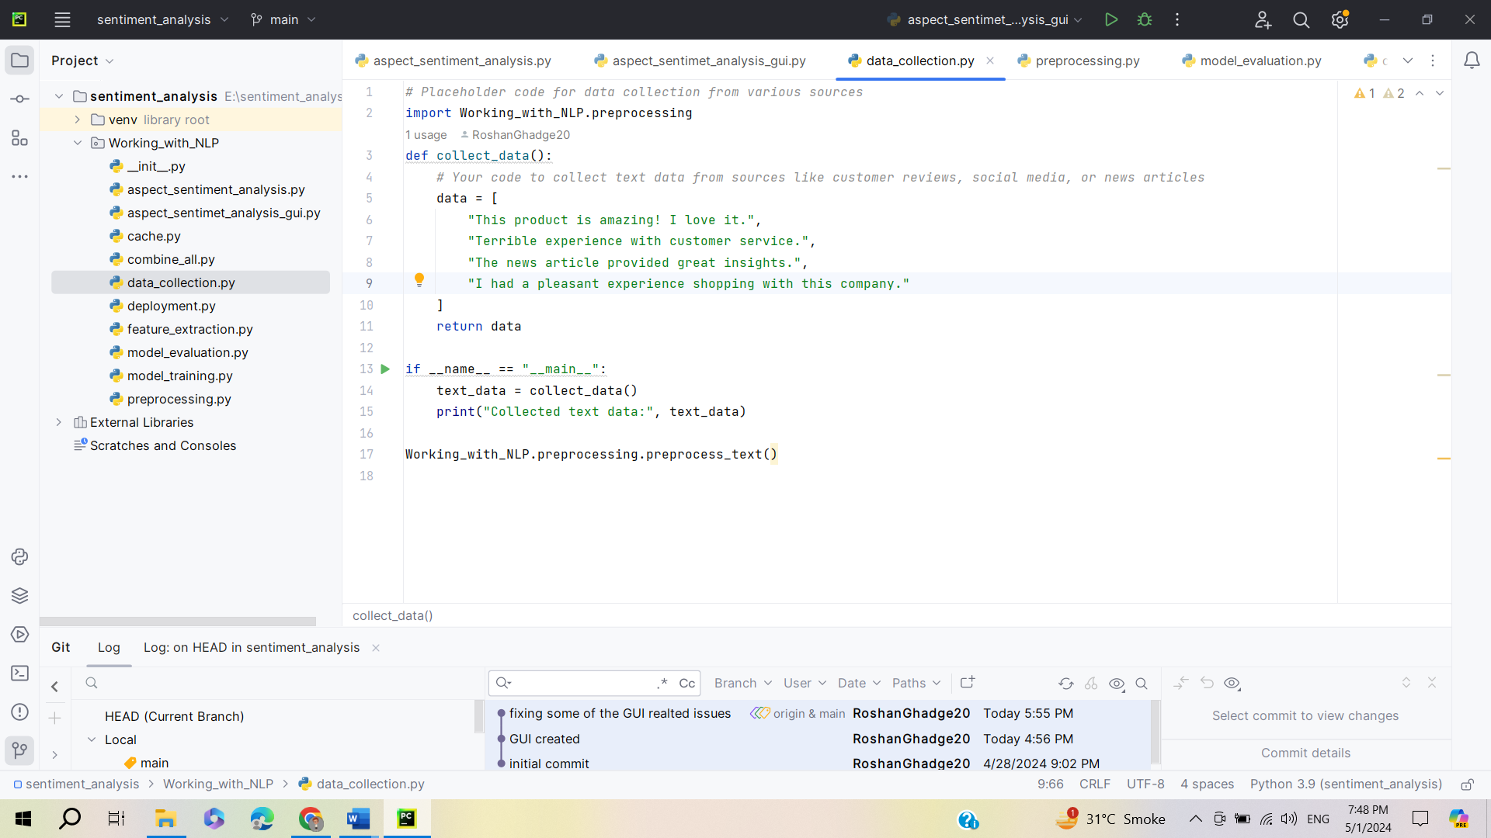

preprocessing.py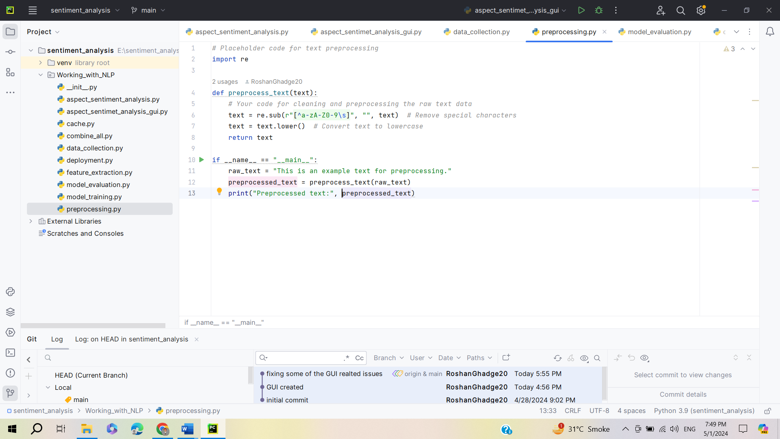

model_evaluation.py  
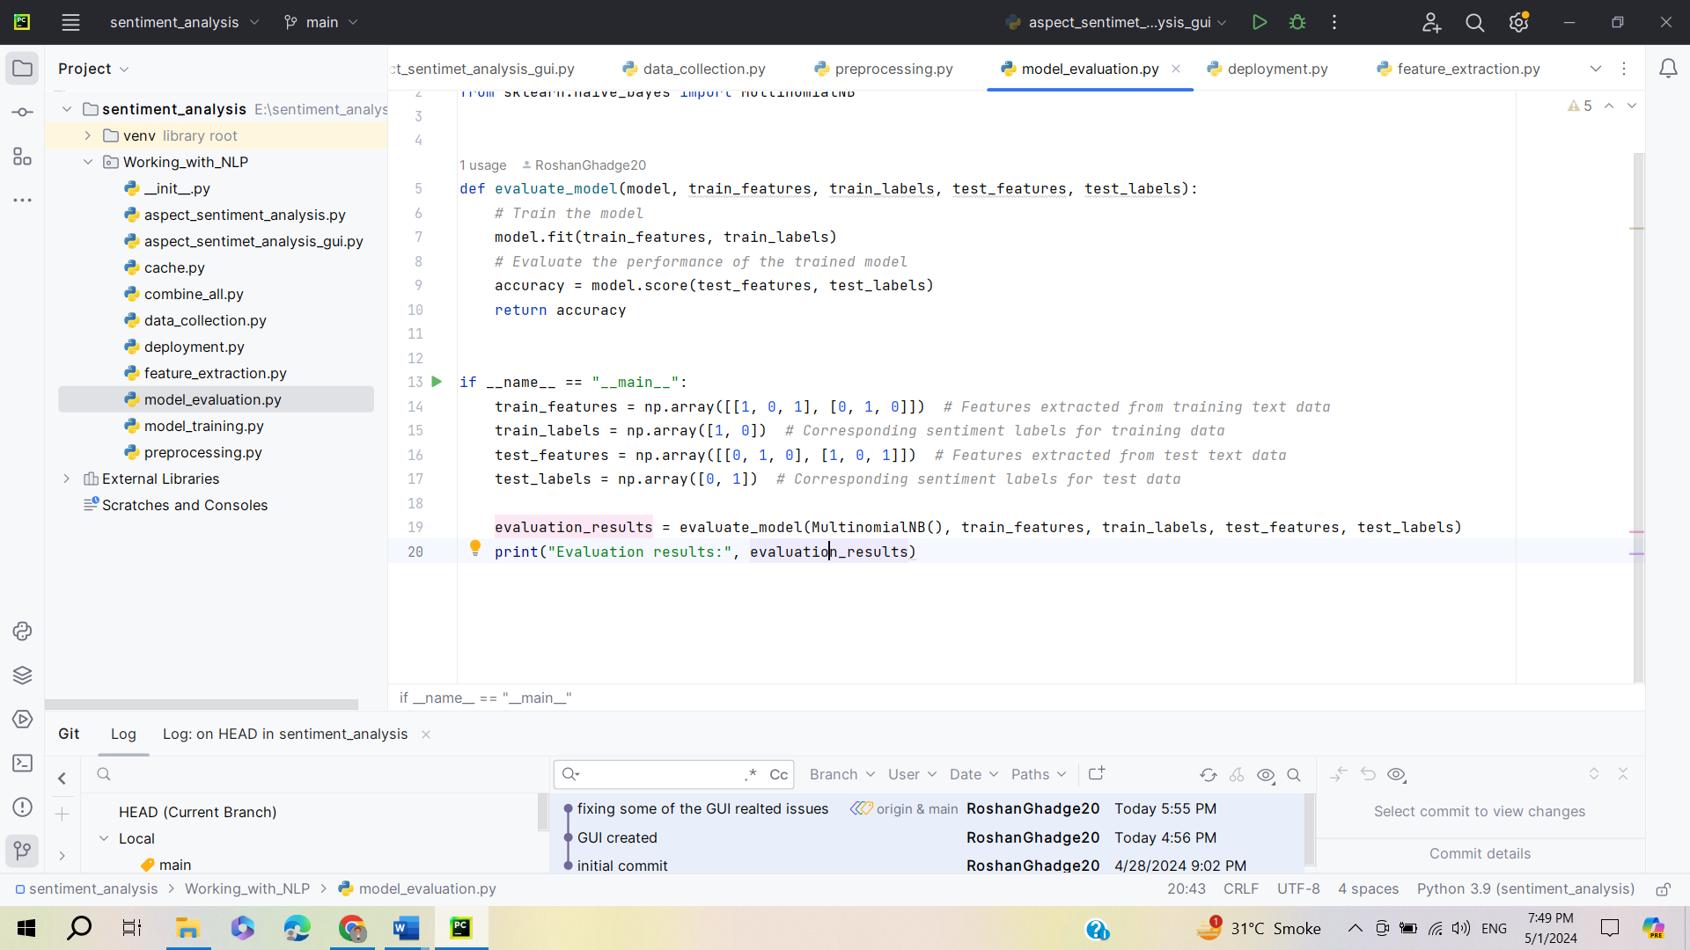

model_training.py  
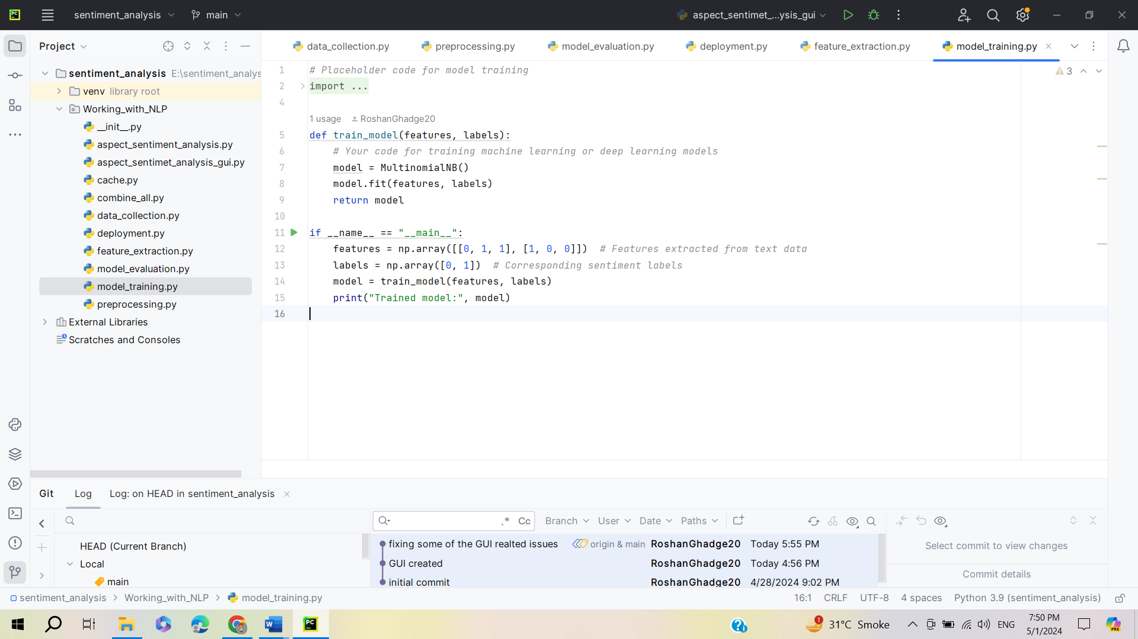

feature_extraction.py  
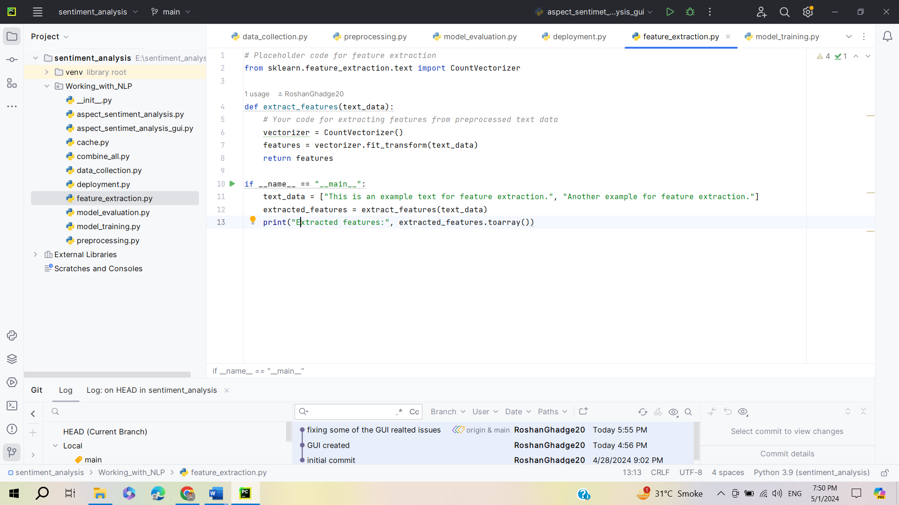

deployment  
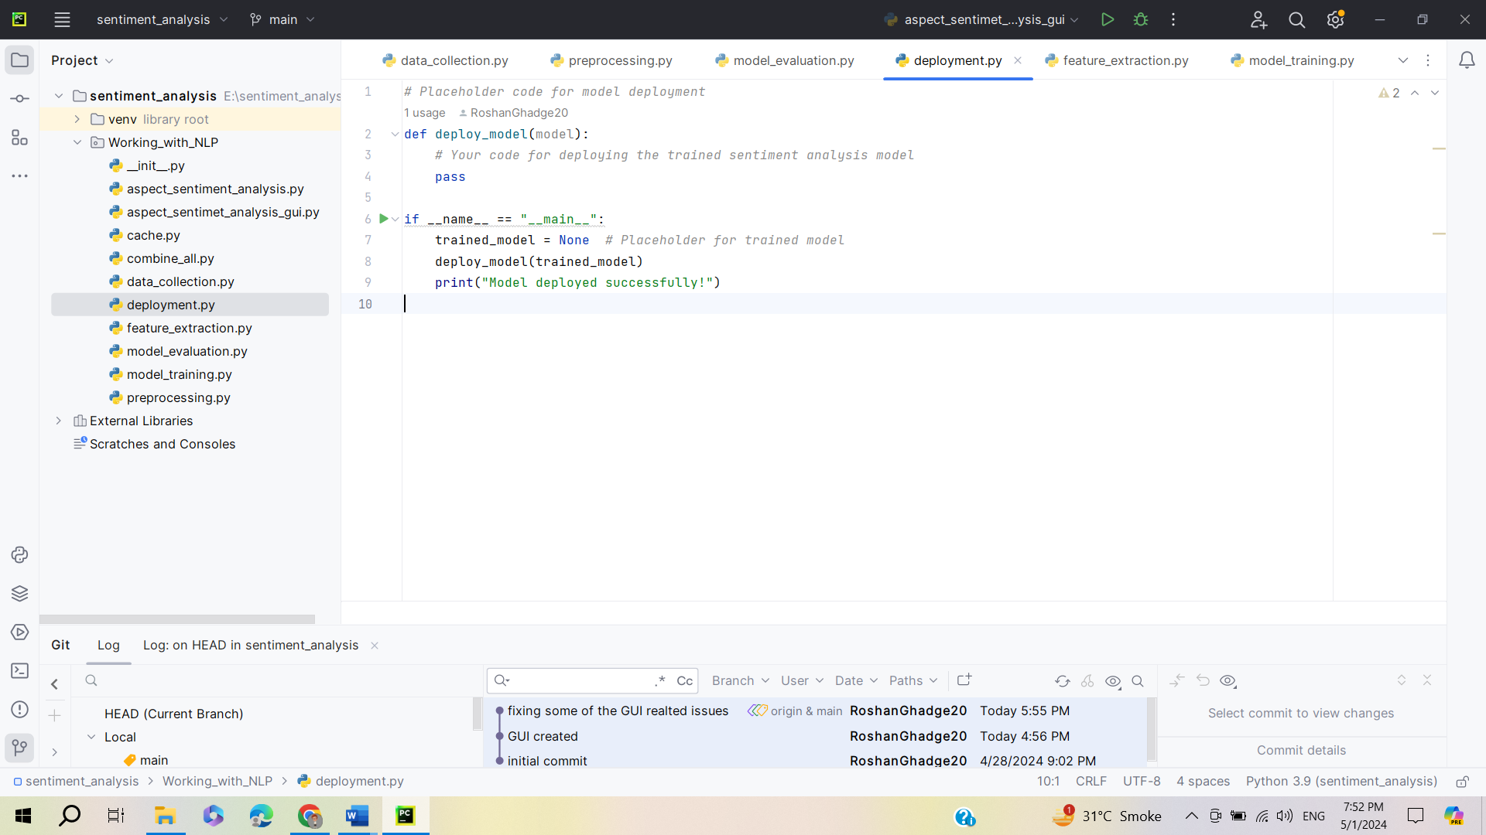

aspect_sentiment_analysis.py  
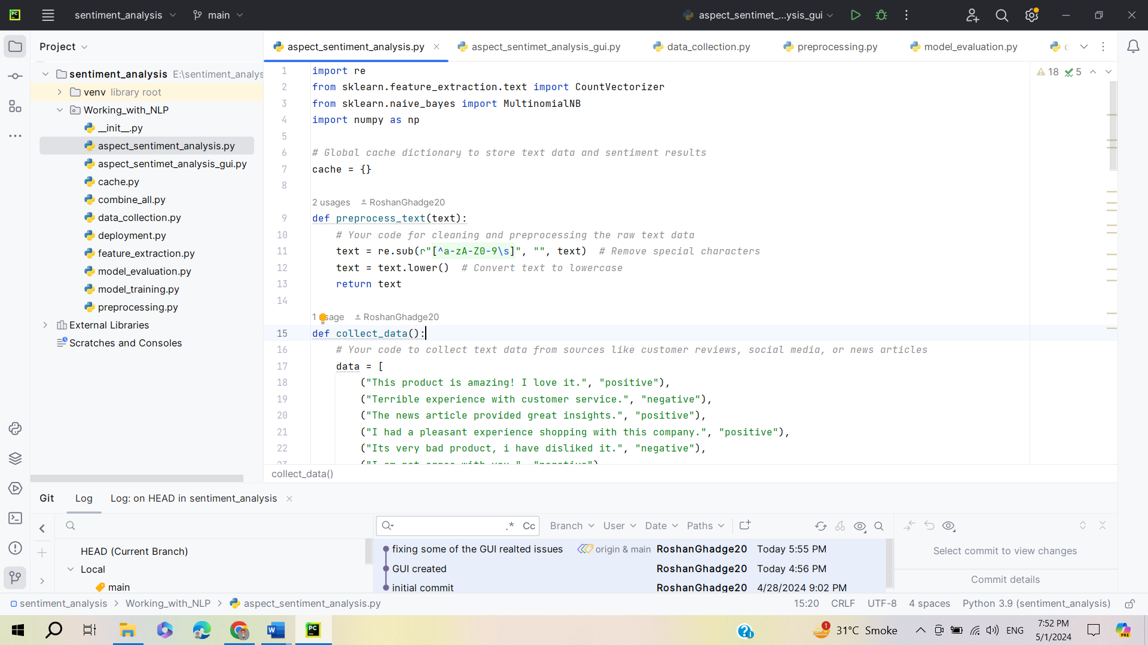

aspect_sentiment_analysis_gui.py  
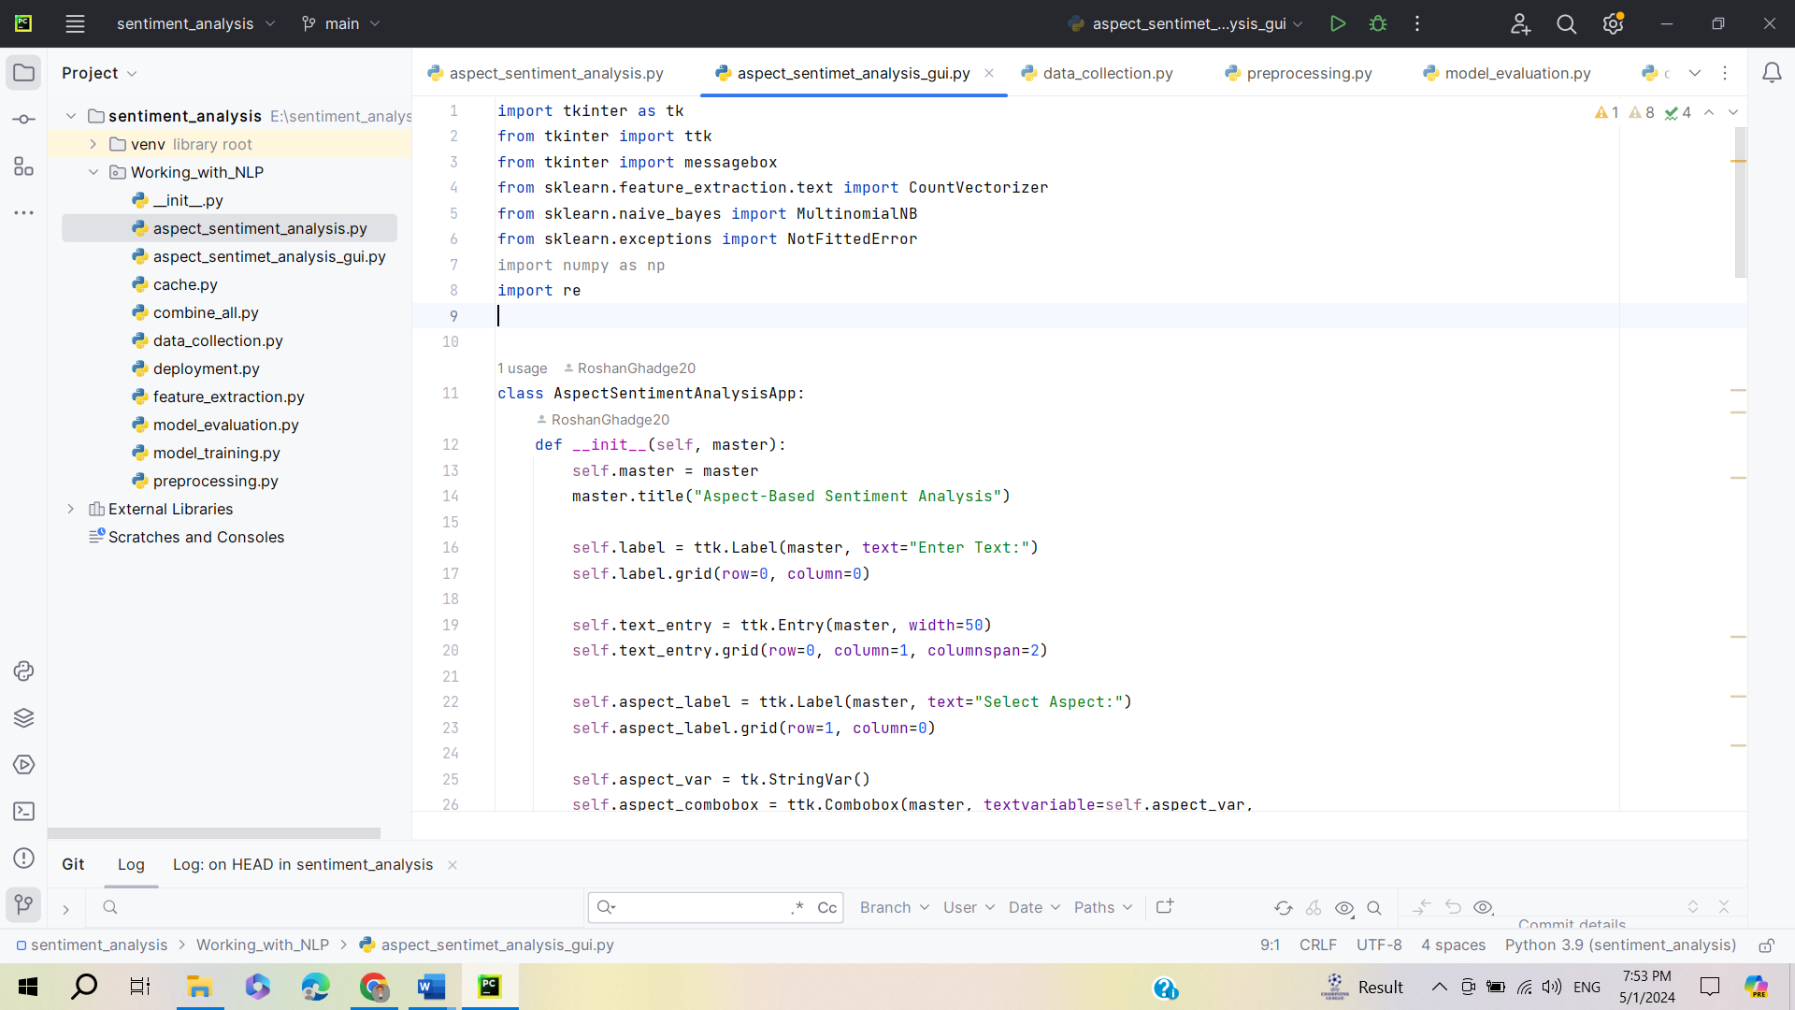

aspect_sentiment_analysis_gui.py 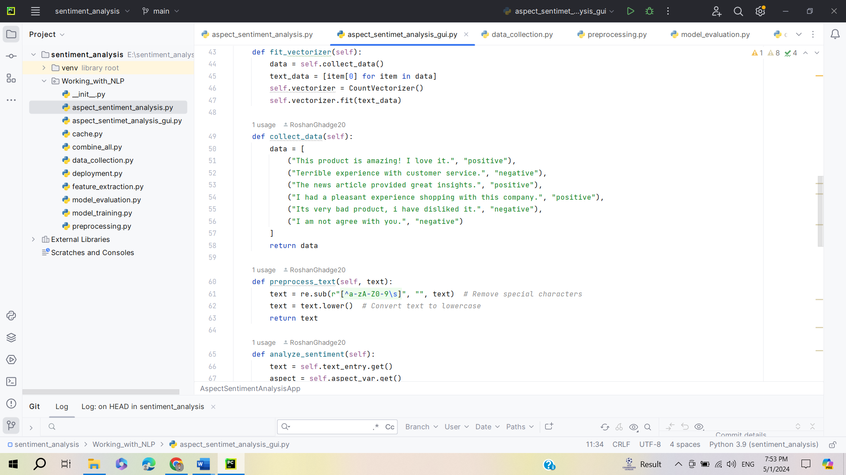

aspect_sentiment_analysis_gui.py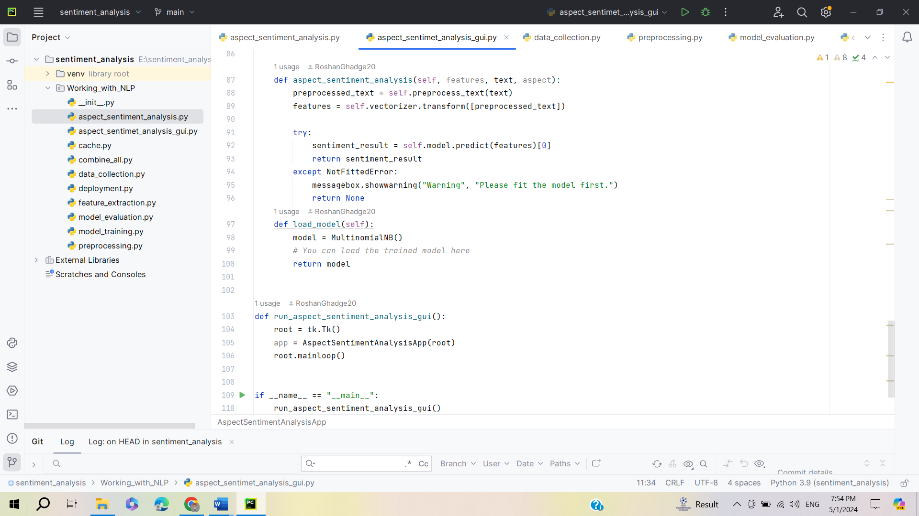

**Output of aspect_sentiment_analysis.py file**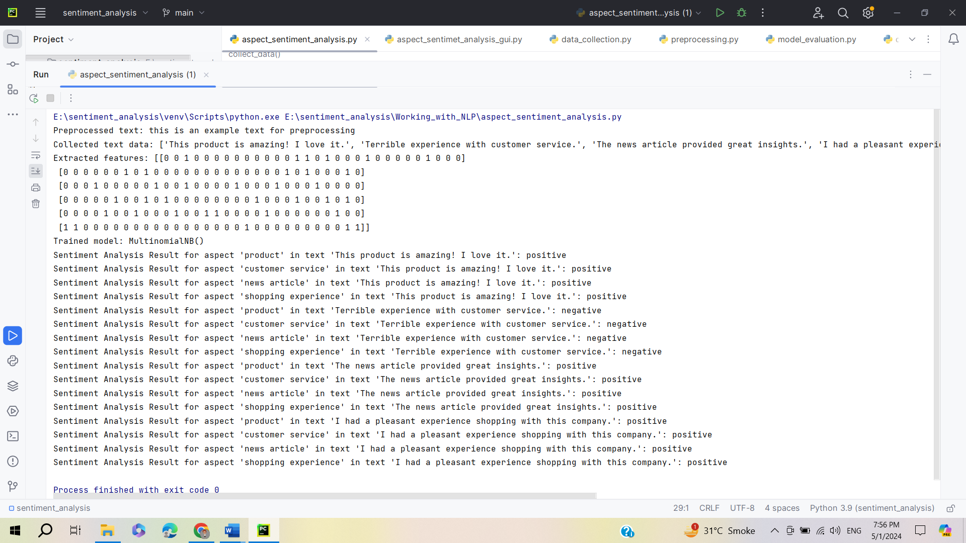

**Output of aspect_sentiment_analysis_gui.py file**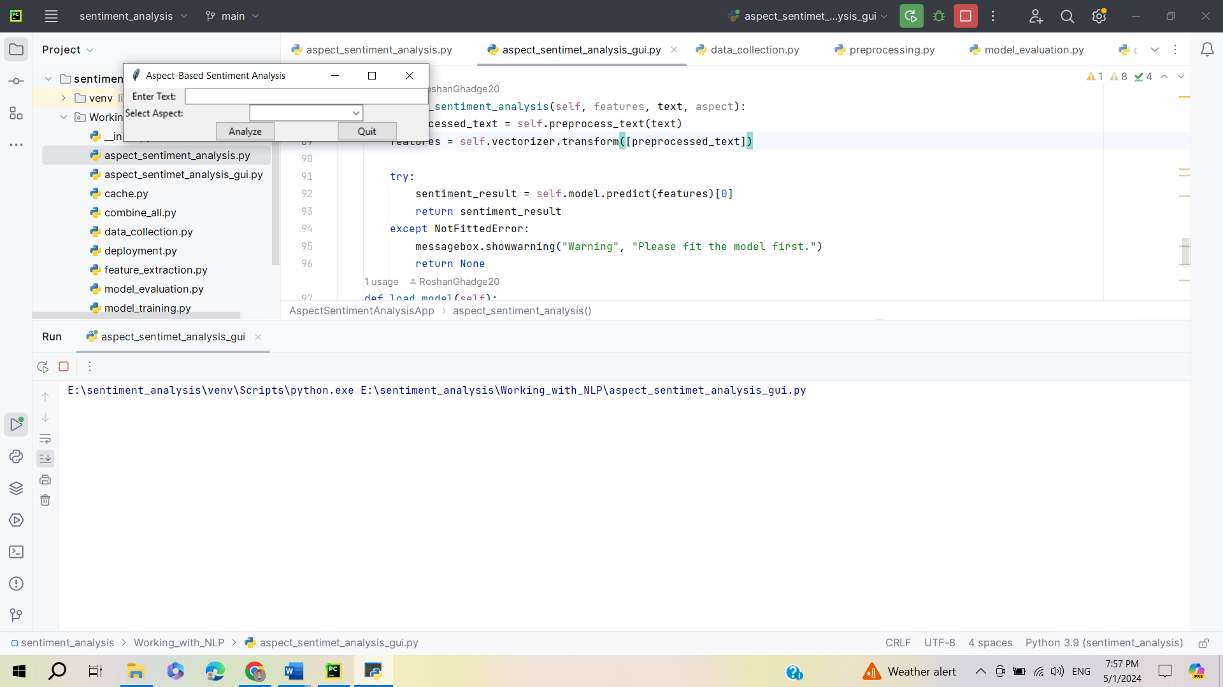

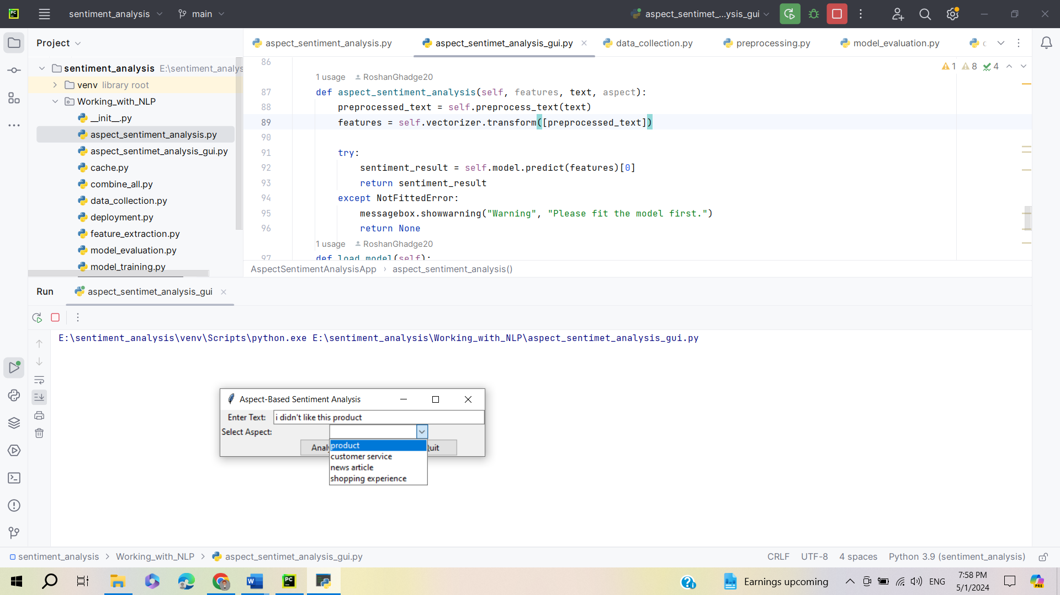

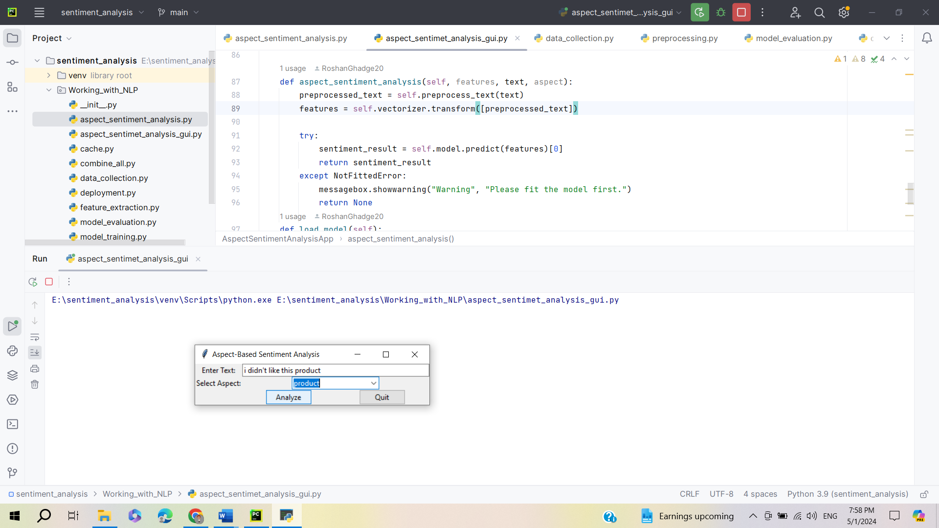

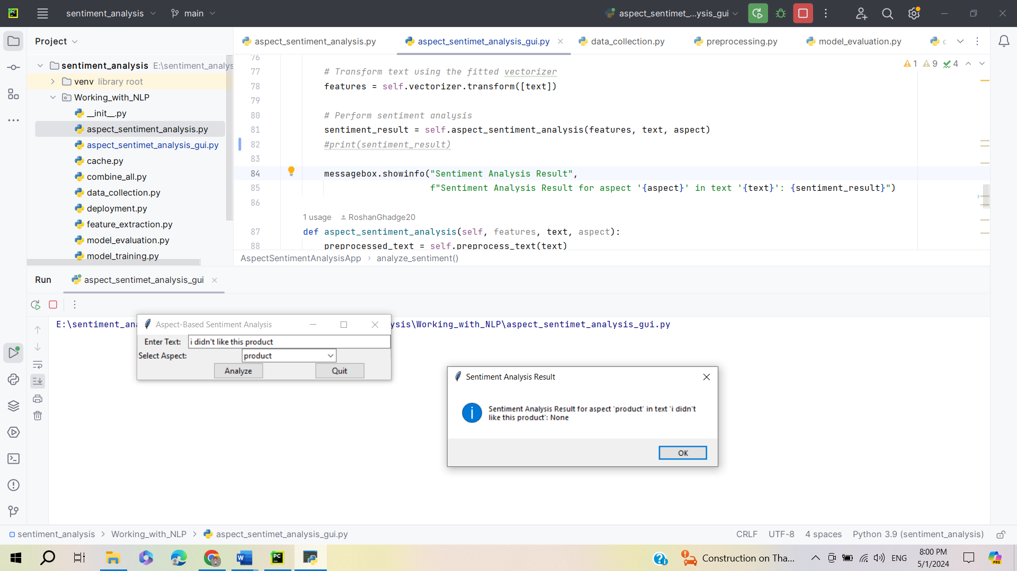

**Chapter 6: Conclusion & Suggestion**

* 1. **Finding**

The findings of an Aspect-Based Sentiment Analysis (ABSA) project provide valuable insights into customer sentiments towards specific aspects or features of products, services, or experiences. Here are some hypothetical findings that could result from an ABSA project:

* **Identification of Key Aspects:** The ABSA analysis identified the most frequently mentioned aspects or features in customer feedback. For example, in a study of smartphone reviews, aspects such as battery life, camera quality, performance, and design were found to be among the most discussed topics.
* **Sentiment Distribution:** The sentiment analysis revealed the distribution of sentiments associated with each aspect. While battery life received predominantly positive sentiments, camera quality and performance showed a mix of positive and negative sentiments, indicating areas for improvement.
* **Aspect-Specific Insights:** The ABSA analysis provided aspect-specific insights into customer perceptions and preferences. For instance, customers praised the battery life for its longevity but expressed dissatisfaction with the camera's low-light performance.
* **Comparison Across Products:** The ABSA project allowed for comparisons across different products or brands within the same category. For example, comparisons between iPhone and Android smartphones revealed differences in customer sentiments towards aspects such as user interface, app ecosystem, and customer support.
* **Temporal Trends:** Analysis of temporal trends showed how sentiments towards specific aspects evolved over time. For instance, sentiments towards a   
    
    
  new software update for a product may have initially been negative due to bugs and issues but improved over time as fixes were implemented.
* **Identification of Influencing Factors:** The ABSA analysis identified factors influencing customer sentiments towards specific aspects. For example, in a study of hotel reviews, aspects such as cleanliness and customer service were found to be strongly correlated with overall satisfaction.
  1. **Suggestion**

For an Aspect-Based Sentiment Analysis (ABSA) project, several suggestions can enhance its effectiveness:

* **Refine Aspect Extraction:** Continuously refine aspect extraction techniques to accurately identify and extract specific aspects or features mentioned in text data. Incorporate domain-specific knowledge and advanced natural language processing (NLP) techniques to improve accuracy.
* **Fine-Tune Sentiment Classification:** Fine-tune sentiment classification models to accurately classify sentiments towards extracted aspects. Experiment with different machine learning and deep learning algorithms, feature representations, and ensemble techniques to improve classification performance.
* **Consider Contextual Understanding:** Enhance models' contextual understanding to capture subtle nuances, such as sarcasm, irony, and implicit sentiment. Explore techniques like contextual embeddings and attention mechanisms to improve sentiment analysis accuracy within the appropriate context.
  1. **Limitations**

Aspect-Based Sentiment Analysis (ABSA) projects may encounter several limitations that could affect the accuracy, reliability, and generalizability of the analysis. Here are some common limitations:

* **Aspect Identification Challenges:** One of the primary challenges in ABSA is accurately identifying and extracting specific aspects or features mentioned in text data. Ambiguity, context-dependence, and variability in expressions can make aspect extraction challenging, leading to errors in sentiment analysis.
* **Data Sparsity and Imbalance:** ABSA models require labelled data for training, and obtaining large, balanced datasets with sufficient coverage of all aspects and sentiments can be challenging. Data sparsity and imbalance may result in biased models and suboptimal performance, especially for minority classes and rare aspects.
* **Contextual Understanding:** ABSA models may struggle with understanding the contextual nuances of language, including sarcasm, irony, and implicit sentiment. Misinterpretations of sentiment expressions can occur, particularly in cases where context is crucial for accurate analysis.
* **Domain Specificity:** ABSA models trained on data from one domain may not generalize well to other domains due to domain-specific language, terminology, and sentiment expressions. Models may require domain adaptation techniques to perform effectively across diverse domains.
* **Subjectivity and Variability:** Sentiment analysis is inherently subjective, and individuals may express different sentiments towards the same aspect or feature. Variability in sentiment expressions and subjective interpretations can introduce noise and uncertainty into ABSA analysis.
  1. **Conclusion**

In conclusion, Aspect-Based Sentiment Analysis (ABSA) projects offer valuable insights into customer sentiments towards specific aspects or features of products, services, or experiences. Despite facing several limitations, including aspect identification challenges, data sparsity, and contextual understanding issues, ABSA projects remain crucial for businesses aiming to understand customer feedback and drive improvements.

Throughout the ABSA project lifecycle, it is essential to address these limitations systematically. Advanced techniques for aspect extraction, sentiment classification, and contextual understanding can enhance accuracy and reliability. Additionally, addressing data sparsity and imbalance through data augmentation and balancing techniques improves model robustness.

Moreover, interpreting and explaining ABSA model decisions through visualization and transparency measures fosters trust among stakeholders. Ethical considerations, such as data privacy and fairness, must guide ABSA projects to ensure responsible use of customer data and prevent biases in sentiment analysis results.

Despite these challenges, ABSA projects provide actionable insights for businesses to make data-driven decisions, enhance products and services, and drive customer satisfaction and loyalty. By acknowledging and mitigating limitations, ABSA projects can continue to deliver meaningful insights and contribute to advancements in sentiment analysis and natural language processing.

**Chapter 7: Learning Experience from the project**

Undertaking an Aspect-Based Sentiment Analysis (ABSA) project offers a rich learning experience that encompasses various facets of natural language processing, machine learning, and data analysis. Through navigating the challenges, leveraging opportunities, and addressing limitations encountered throughout the project lifecycle, valuable insights are gained, contributing to personal and professional growth. Here's a detailed exploration of the learning experience derived from an ABSA project:

* **Technical Skills Development:**
* **Natural Language Processing (NLP):** The project provides an opportunity to deepen understanding and application of NLP techniques, including text preprocessing, feature engineering, and sentiment analysis algorithms.
* **Machine Learning and Deep Learning:** Leveraging machine learning and deep learning models for aspect extraction, sentiment classification, and fine-grained sentiment analysis enhances proficiency in model development and optimization.
* **Statistical Techniques:** Applying statistical techniques such as frequency analysis, correlation analysis, and topic modeling fosters proficiency in extracting insights from textual data and understanding sentiment trends.
* **Data Collection and Preprocessing:** Learning to collect, clean, and preprocess textual data from various sources improves skills in data acquisition, cleaning, and transformation, essential for effective analysis.
* **Problem-Solving and Critical Thinking:**
* **Aspect Identification Challenges:** Addressing aspect identification challenges requires critical thinking and problem-solving skills to design effective solutions and improve accuracy.
* **Data Sparsity and Imbalance:** Dealing with data sparsity and imbalance necessitates creative strategies for data augmentation, sampling, and balancing to mitigate biases and improve model performance.
* **Contextual Understanding:** Overcoming contextual understanding issues involves critically analyzing language nuances, exploring contextual embeddings, and devising approaches to capture subtle sentiment expressions accurately.
* **Ethical Considerations and Responsible AI:**
* **Data Privacy and Fairness:** Considering data privacy regulations and ensuring fairness in model development highlight the importance of ethical considerations in AI projects. Learning to navigate ethical dilemmas and mitigate biases enhances awareness of responsible AI practices.
* **Transparency and Explainability:** Striving for model transparency and explainability fosters trust among stakeholders and reinforces ethical principles. Understanding the importance of transparency in model decisions and communicating results effectively is a valuable takeaway.
* **Interdisciplinary Learning:**
* **Business Understanding:** Collaborating with stakeholders to understand business objectives and translate them into analytical tasks fosters interdisciplinary learning. Bridging the gap between technical expertise and business needs enhances communication skills and strengthens project alignment with organizational goals.
* **Domain Knowledge Acquisition:** Acquiring domain-specific knowledge in diverse industries enriches understanding of customer preferences, market dynamics, and industry-specific challenges. Incorporating domain expertise into analysis improves the relevance and impact of insights generated.
* **Continuous Learning and Adaptability:**
* **Iterative Improvement:** Embracing an iterative approach to model development and evaluation fosters a mindset of continuous learning and improvement. Iteratively refining models based on feedback and performance metrics cultivates adaptability and resilience in addressing challenges.
* **Keeping Pace with Advancements:** Staying updated with the latest advancements in NLP, machine learning, and AI ensures relevance and effectiveness in ABSA projects. Actively seeking opportunities for learning and skill development enables adaptation to evolving methodologies and techniques.
* **Communication and Collaboration:**
* Effective Communication: Communicating findings, insights, and recommendations to diverse stakeholders requires clarity, conciseness, and adaptability in communication styles. Practicing effective communication skills enhances the ability to convey complex technical concepts to non-technical audiences.
* Collaborative Problem-Solving: Collaborating with team members, domain experts, and stakeholders fosters a collaborative problem-solving approach. Leveraging diverse perspectives and expertise enhances creativity, innovation, and problem-solving effectiveness.

**Annexure**

**Questionaries for Aspect Based Sentiment Analysis**

* **Data Collection:**
* What are the primary sources of textual data being used for aspect-based sentiment analysis in this project?
* How are the textual data sources selected to ensure relevance and representativeness for the analysis?
* What techniques are employed for data collection, annotation, and preprocessing to prepare the data for sentiment analysis?
* **Aspect Identification:**
* How are specific aspects or features of products, services, or experiences identified and extracted from the textual data?
* What challenges are encountered in aspect identification, and how are they addressed to improve accuracy and reliability?
* Are there any domain-specific considerations or techniques employed for aspect extraction in the project?
* **Sentiment Analysis:**
* What methods or algorithms are utilized for sentiment classification and fine-grained sentiment analysis?
* How are sentiment scores or labels assigned to extracted aspects, and what criteria are used for determining sentiment polarity?
* What evaluation metrics are employed to assess the performance of sentiment analysis models?
* **Model Development:**
* What machine learning or deep learning techniques are employed for aspect-based sentiment analysis?
* How are the models trained, validated, and optimized to ensure robustness and generalizability across different domains and datasets?
* Are there any novel architectures or approaches explored for improving aspect-based sentiment analysis performance?
* **Evaluation and Validation:**
* How is the performance of aspect-based sentiment analysis models evaluated and validated?
* Are there any benchmark datasets or gold standards used for comparison and validation purposes?
* What techniques are employed for cross-validation, hyperparameter tuning, and model selection to ensure optimal performance?
* **Impact and Applications:**
* What are the potential applications and use cases of aspect-based sentiment analysis findings in real-world scenarios?
* How do the insights derived from the analysis contribute to decision-making, product development, and customer satisfaction enhancement?
* What actionable recommendations or insights are generated from the aspect-based sentiment analysis project?

**Bibliography**

* Books
* Liu, B. (2012). Sentiment Analysis and Opinion Mining. Morgan & Claypool Publishers. [Book]
* Pontiki, M., Galanis, D., Papageorgiou, H., Androutsopoulos, I., & Manandhar, S. (2016). SemEval-2016 Task 5: Aspect Based Sentiment Analysis. Proceedings of the 10th International Workshop on Semantic Evaluation (SemEval-2016).
* Wang, Y., Huang, M., Zhu, X., Zhao, L., & Yu, Y. (2017). Attention-based LSTM for Aspect-level Sentiment Classification. Proceedings of the 2017 Conference on Empirical Methods in Natural Language Processing (EMNLP).
* Links:
* <https://www.sciencedirect.com/topics/computer-science/aspect-based-sentiment-analysis#:~:text=Aspect%2Dbased%20sentiment%20analysis%3A%20A,of%20a%20product%20or%20service>.
* <https://nlp.stanford.edu/IR-book/>
* <https://www.deeplearningbook.org/>